Practical No.6

Design and develop time-slice simulation for a scenario like airport model to

design how passengers move within a small airport that hosts two airlines, each

with their own gate. Passengers arrive at the airport, check in, pass the security

checkpoint and then go to the waiting area. After boarding starts, each airline’s

representatives check their passengers’ tickets before they allow them to board.

Create a new model and name it Airport. Select minutes as the model time

units.

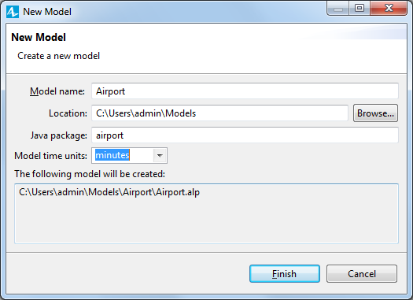

Drag an **Image** from the **Presentation** palette on to the Main diagram.

Choose the image file you want to display. In this example, you’ll select the

*terminal.png* image file from *AnyLogic folder/resources/AnyLogic in 3*

*days/Airport*

On the Main diagram, place the image in the blue frame’s lower left corner. If

the image is distorted, click the **Reset to original size** button and then select

the **Lock** checkbox to lock the image shape..

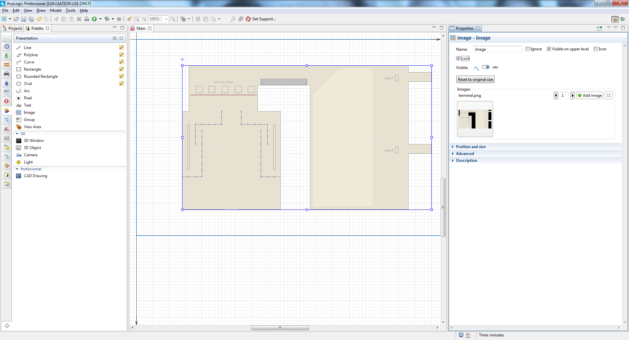

Use the **Pedestrian Library** palette to draw the airport’s walls. Double-click

the **Wall** element you’ll find in the **Pedestrian Library** palette’s **Space**

**markup** section and then draw the wall around the airport building’s border

by clicking your mouse each time you want to add a point. When you’re ready

to set the wall’s final point, double-click your mouse.

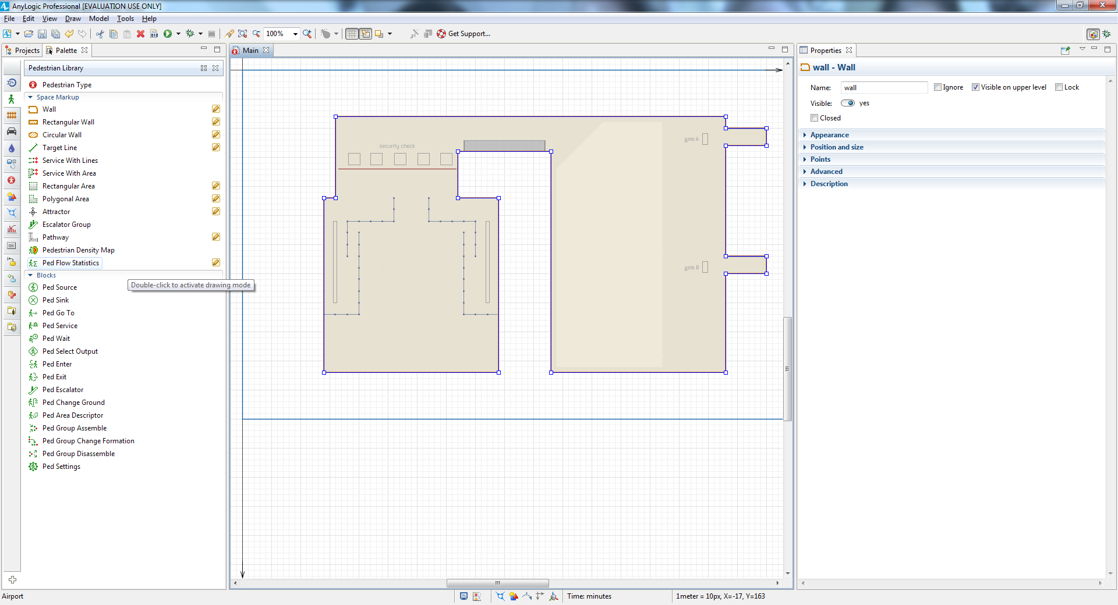

Navigate to the wall’s properties and then select the **Color**: dodgerBlue in the

**Appearance** section.

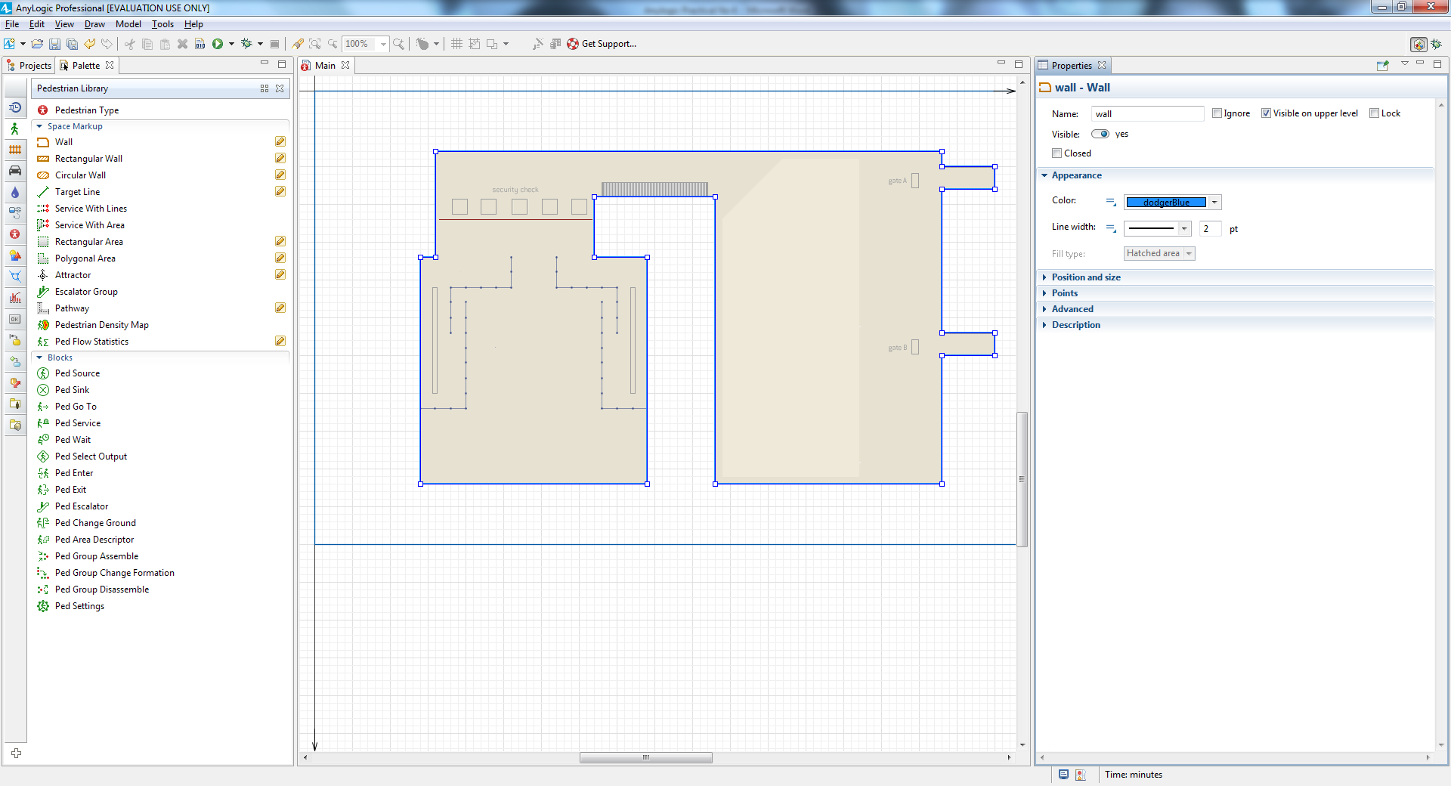

Define the location where your model’s passengers appear by dragging the

**Target Line** element from the **Pedestrian Library** palette on to the graphical

diagram, as shown in the figure below.

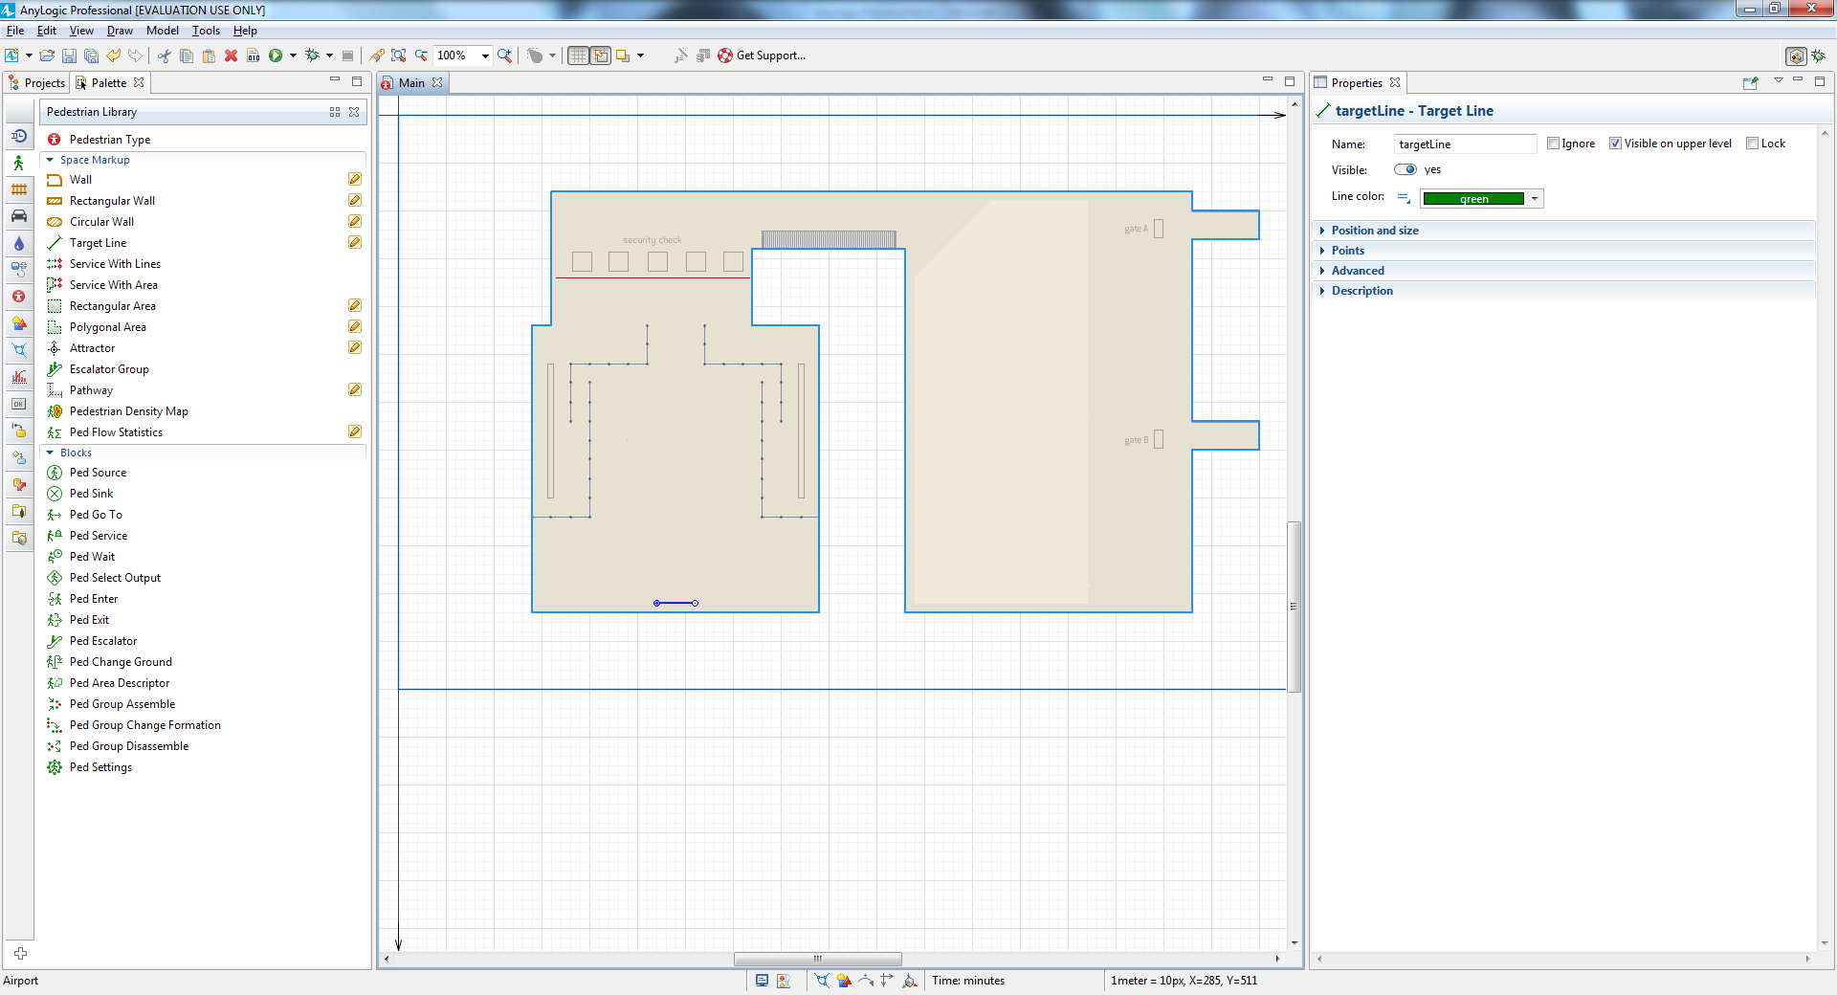

Define a second target line that passengers will move toward after they enter

the airport, place it in the gate area as shown in the figure below, and then

name it gateLine1.

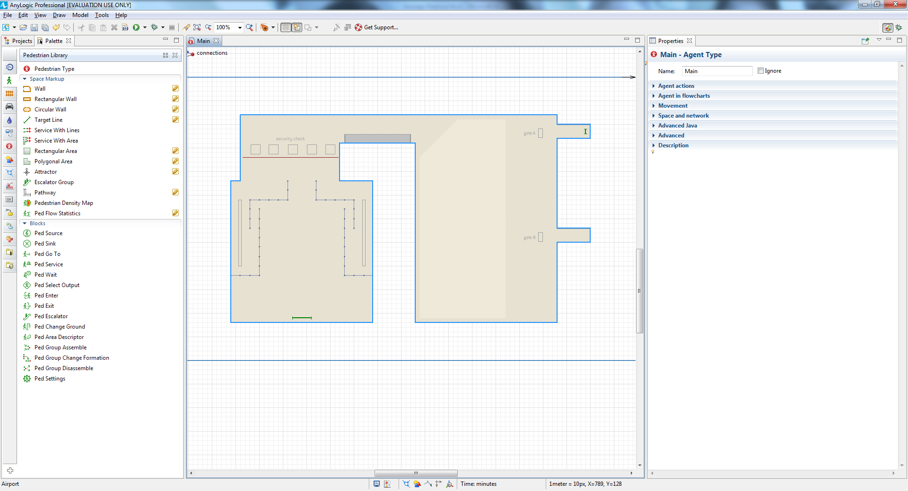

Start by dragging the **PedSource** block from the **Pedestrian Library** palette

on to our Main diagram.

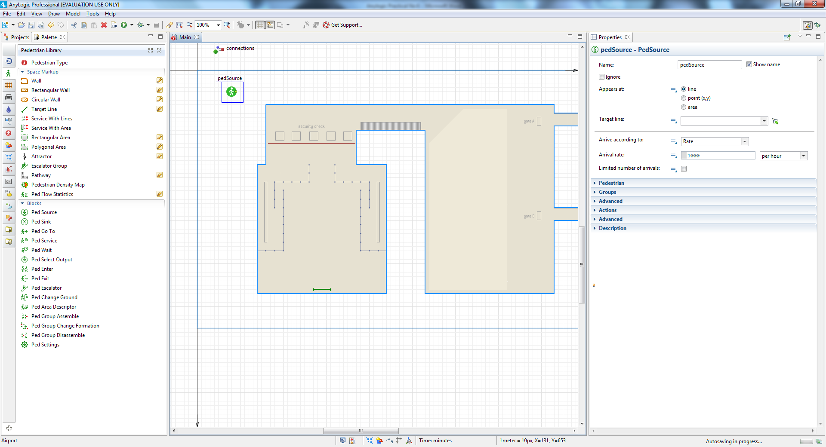

Since we want passengers to arrive randomly at an average rate of 100

passengers per hour, go to the pedSource block properties and then type 100

in the **Arrival rate** box.

Specify the location where the passengers appear in the simulated system by

clicking arrivalLine in the **Target line** list.

Add a **PedGoTo** block to simulate pedestrian movement to the specified

location and then connect it to pedSource. Since we want our passengers to go

to the gate, name the object goToGate1.

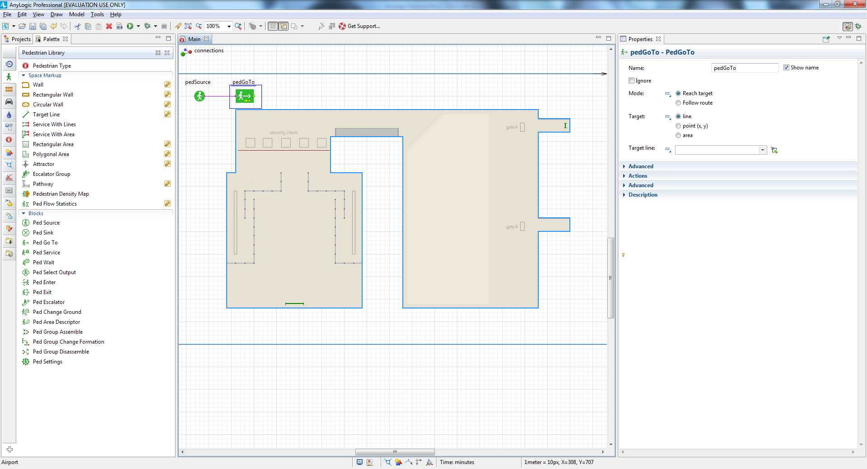

Specify the movement destination by selecting gateLine1 from the **Target line**

combo box.

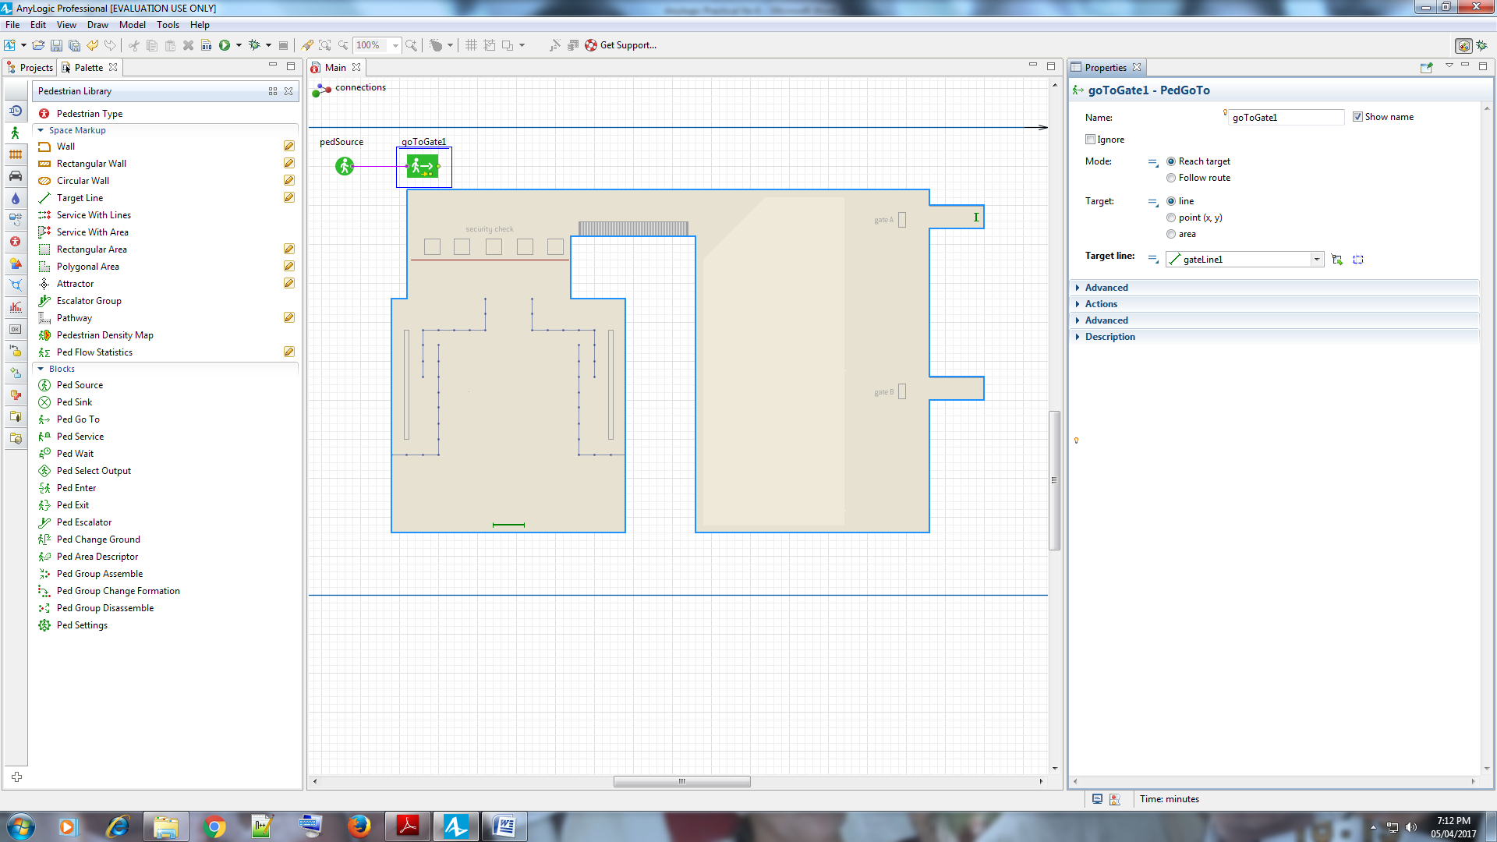

Add a **PedSink** block to discard incoming pedestrians. Pedestrian

flowcharts typically start with a **PedSource** block and end with a **PedSink** block.

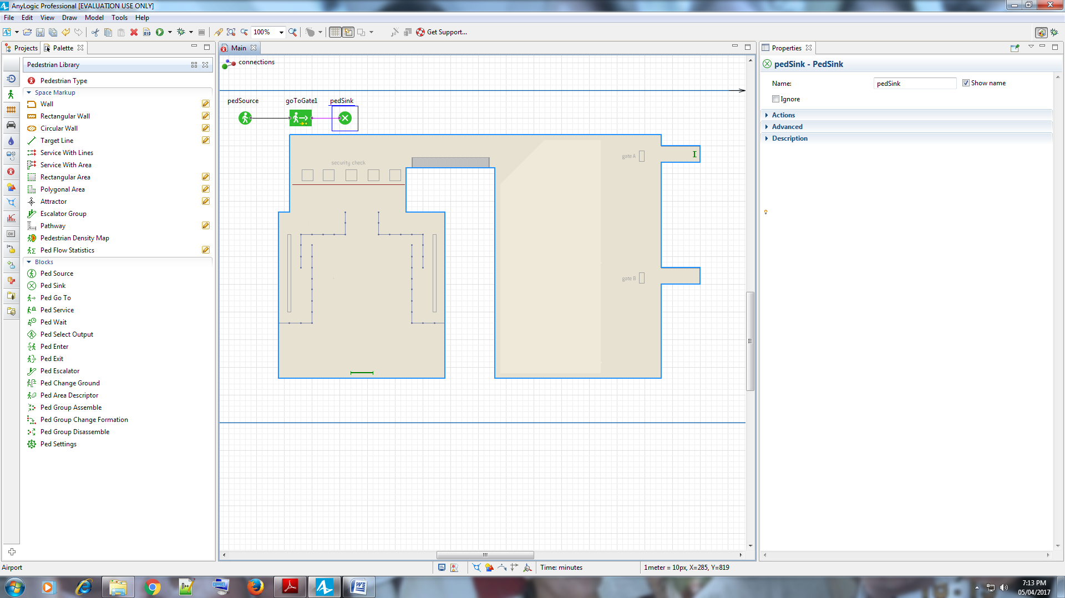

Run the model. In the 2D animation, you’ll see the pedestrians move from the

airport entrance to the gate.

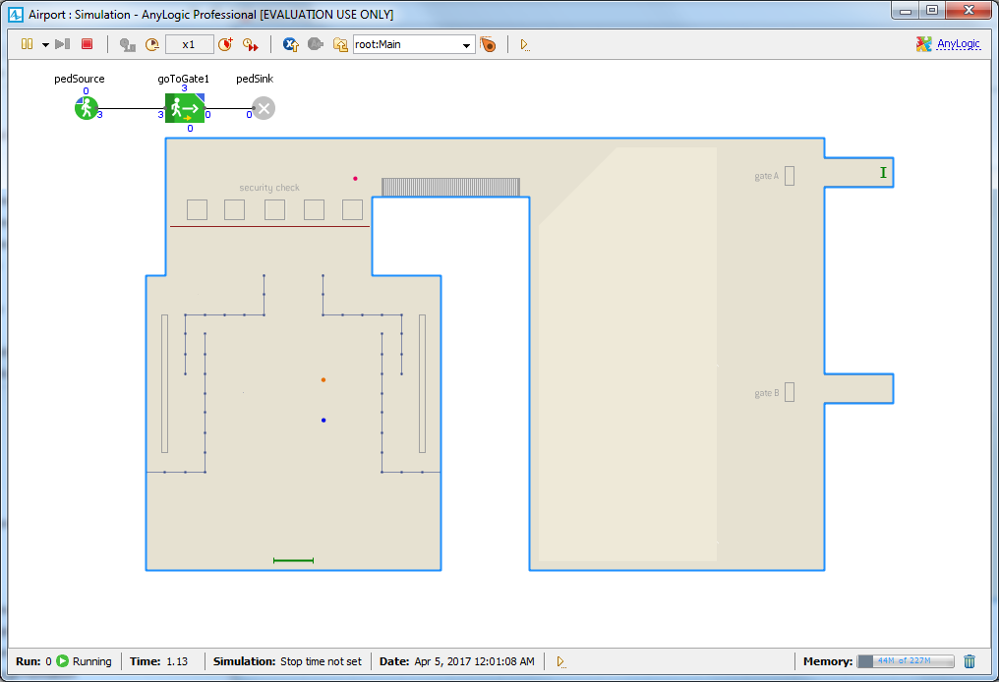

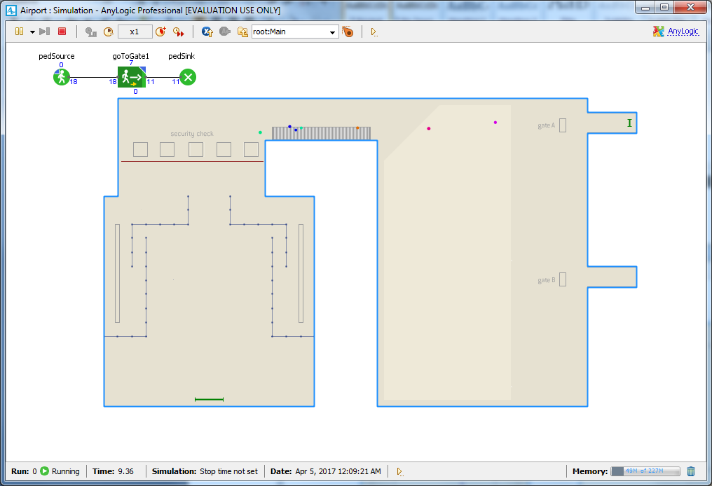

**Drawing 3D animation**

From the **Pedestrian Library** palette, drag the **Pedestrian Type** element on

to the Main diagram.

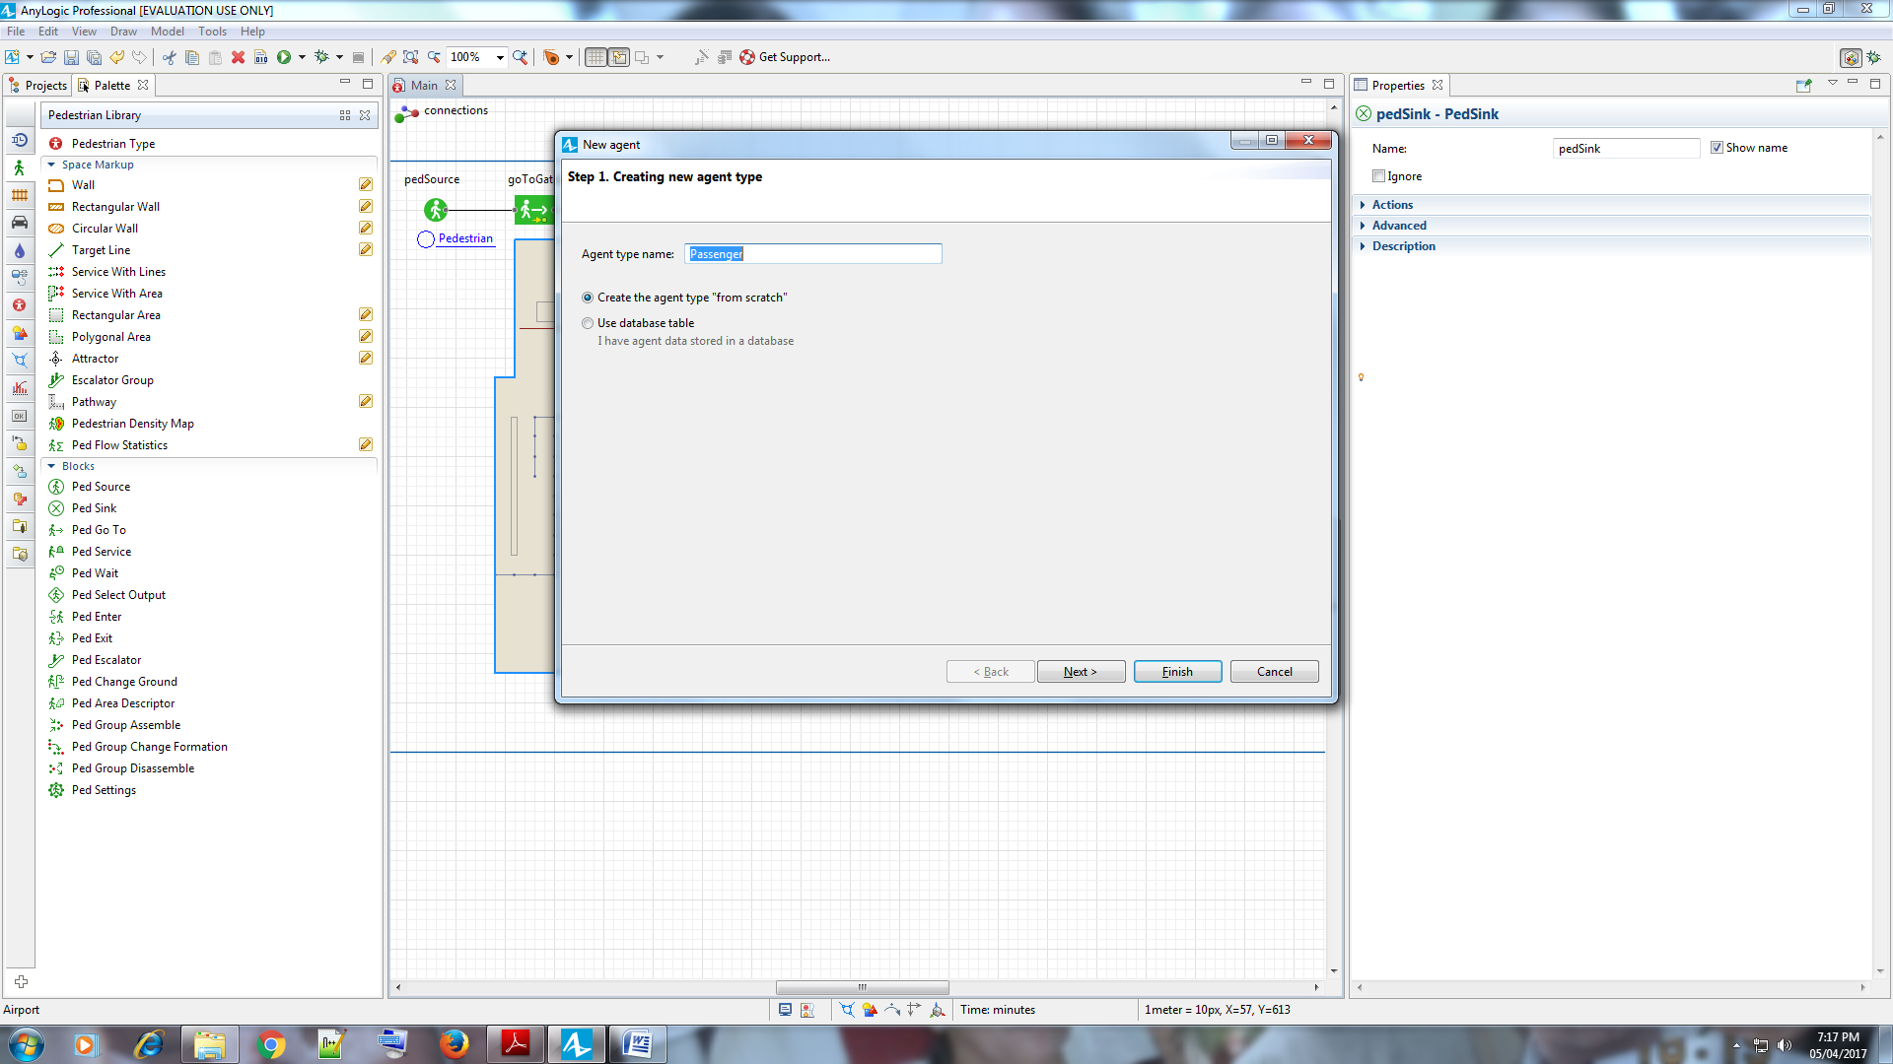

In the **New agent** wizard, enter the new pedestrian type’s name – Passenger –

and then click **Next**.

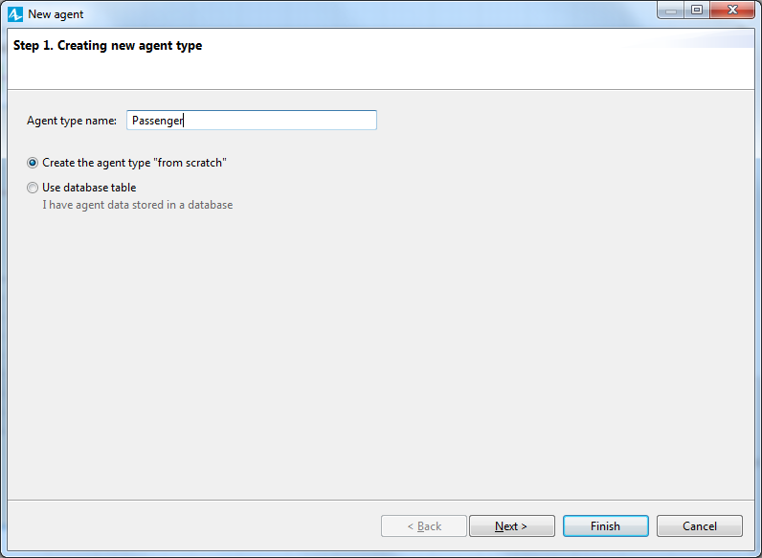

On the **Agent animation** page, select the **General** list’s first item: **Person**, and

click **Finish**.

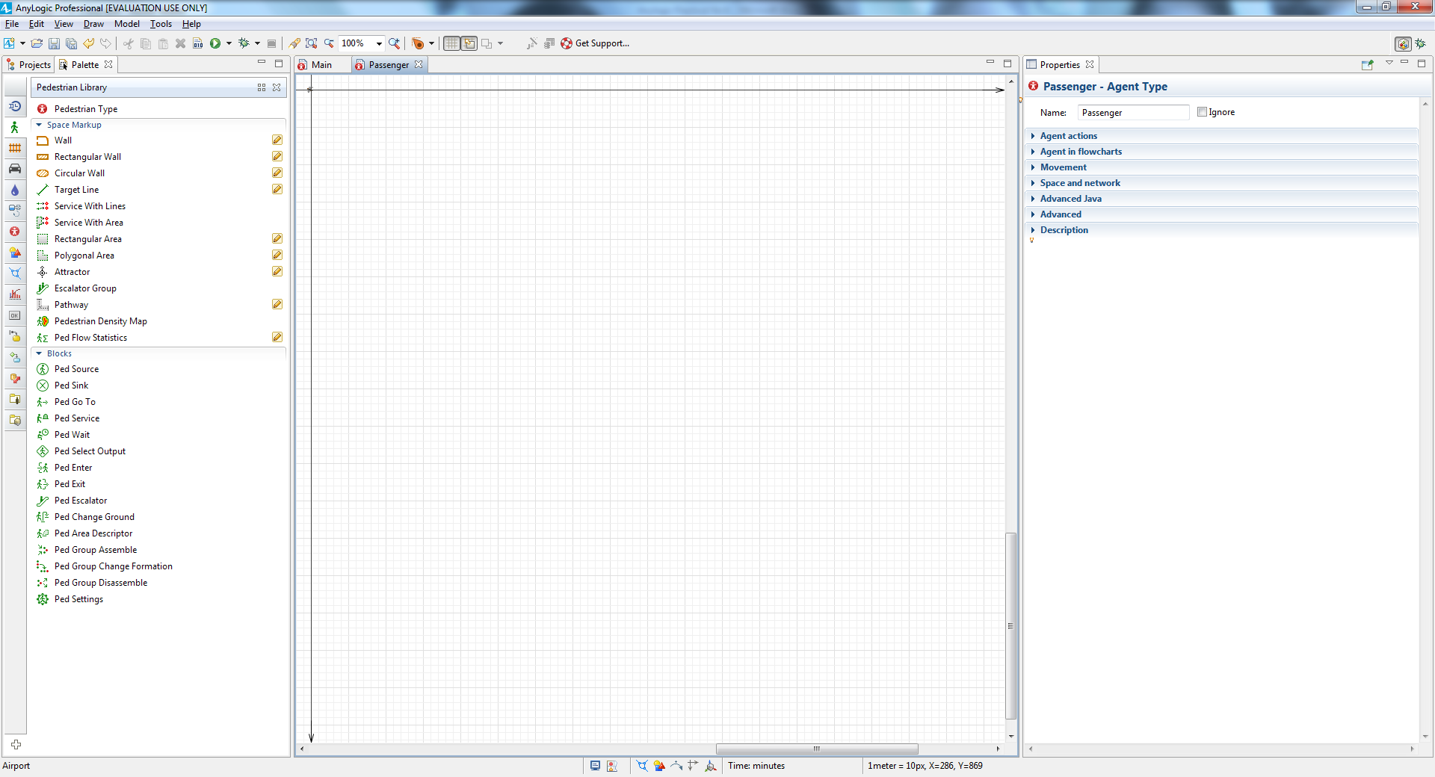

After the Passenger diagram opens, return to the Main diagram.

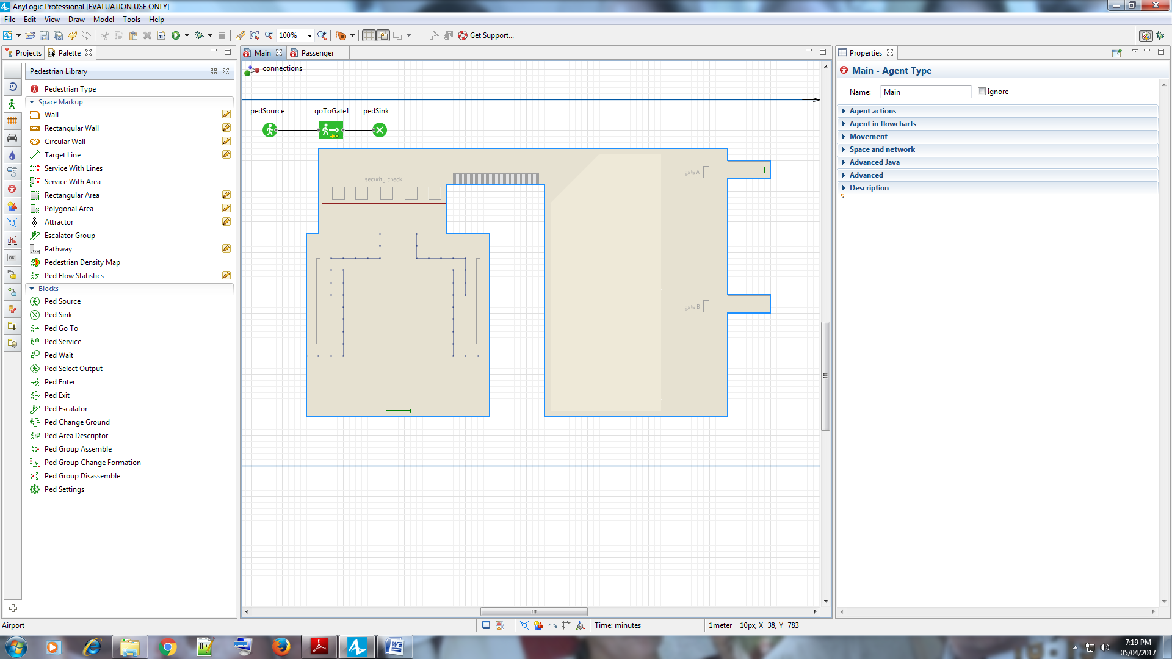

From the **Presentation** palette, drag the **Camera** on to the Main diagram

and place it so it faces the terminal.

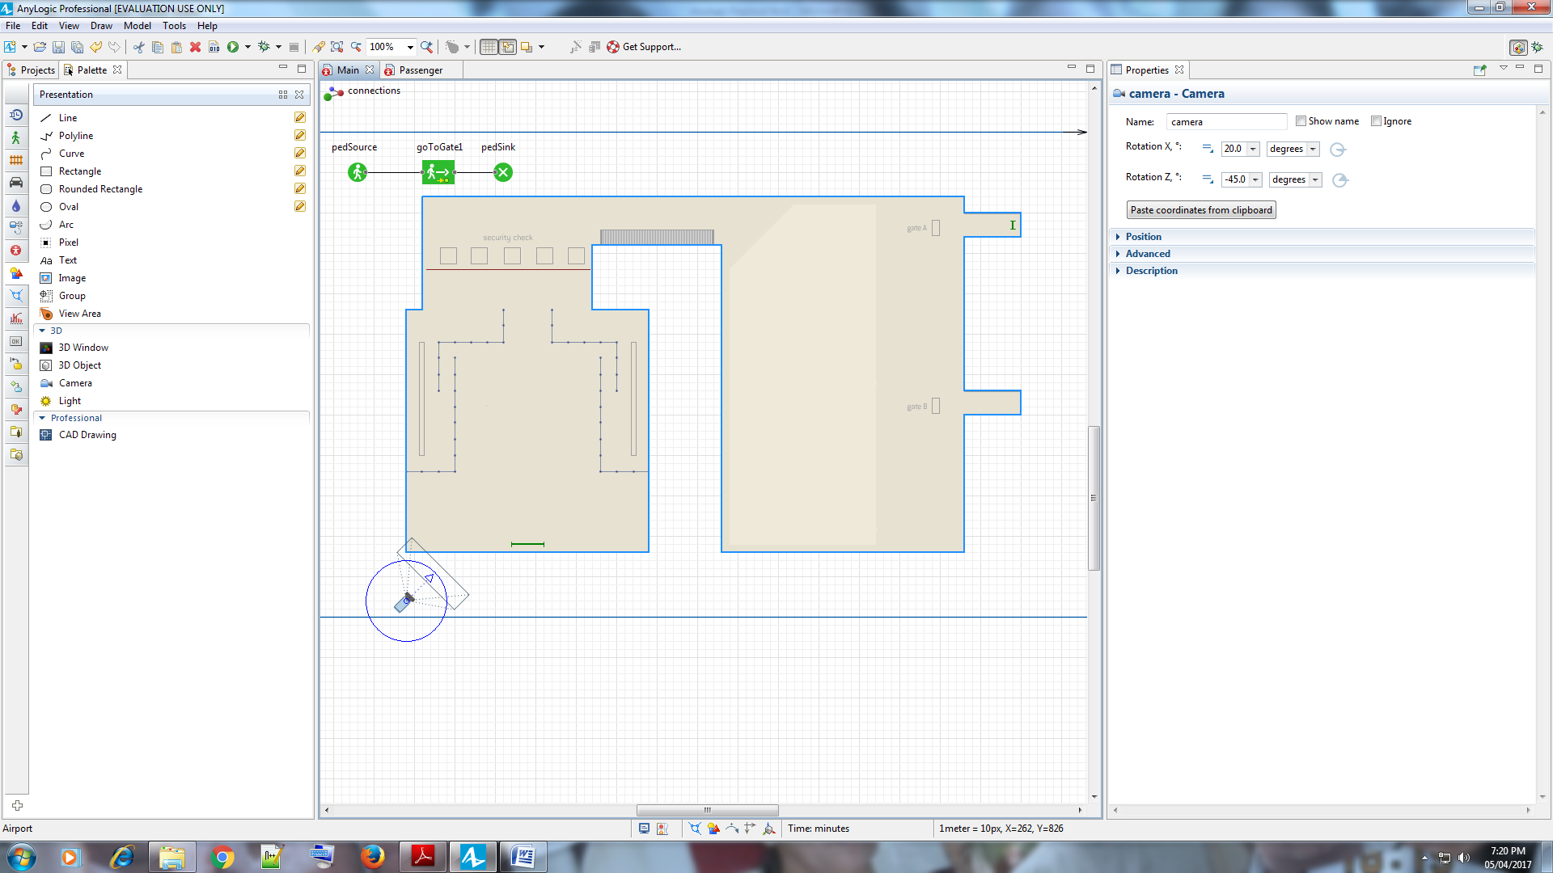

Drag the **3D Window** on to the Main diagram and place it below the

terminal layout image.

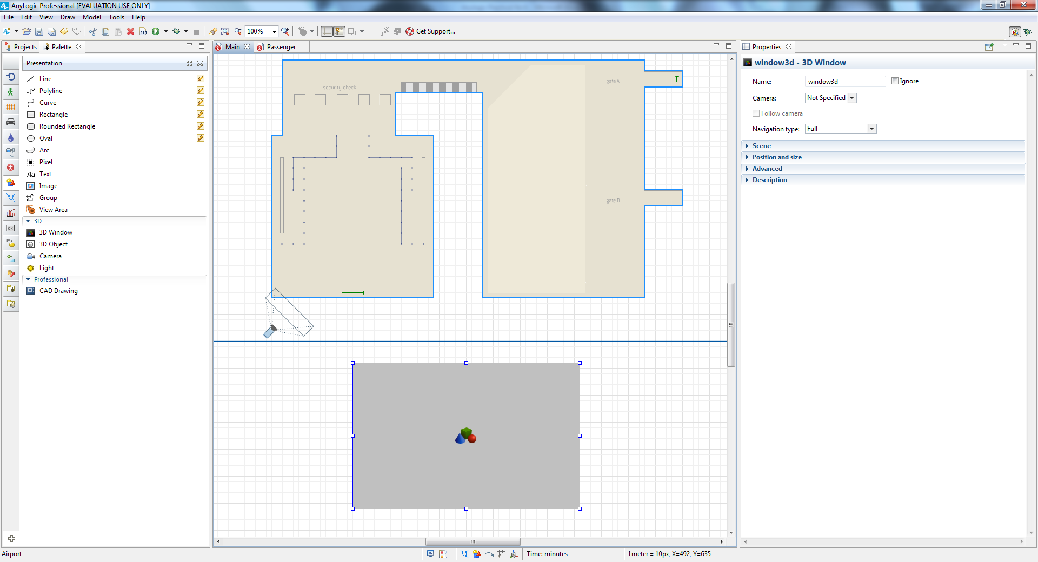

Open the **3D Window** properties, and then select camera from the **Camera** list.

We want our flowchart block pedSource to create pedestrians of our custom

Passenger type. Open the pedSource properties, and then select Passenger

from the **New pedestrian** box in the **Pedestrian** section.

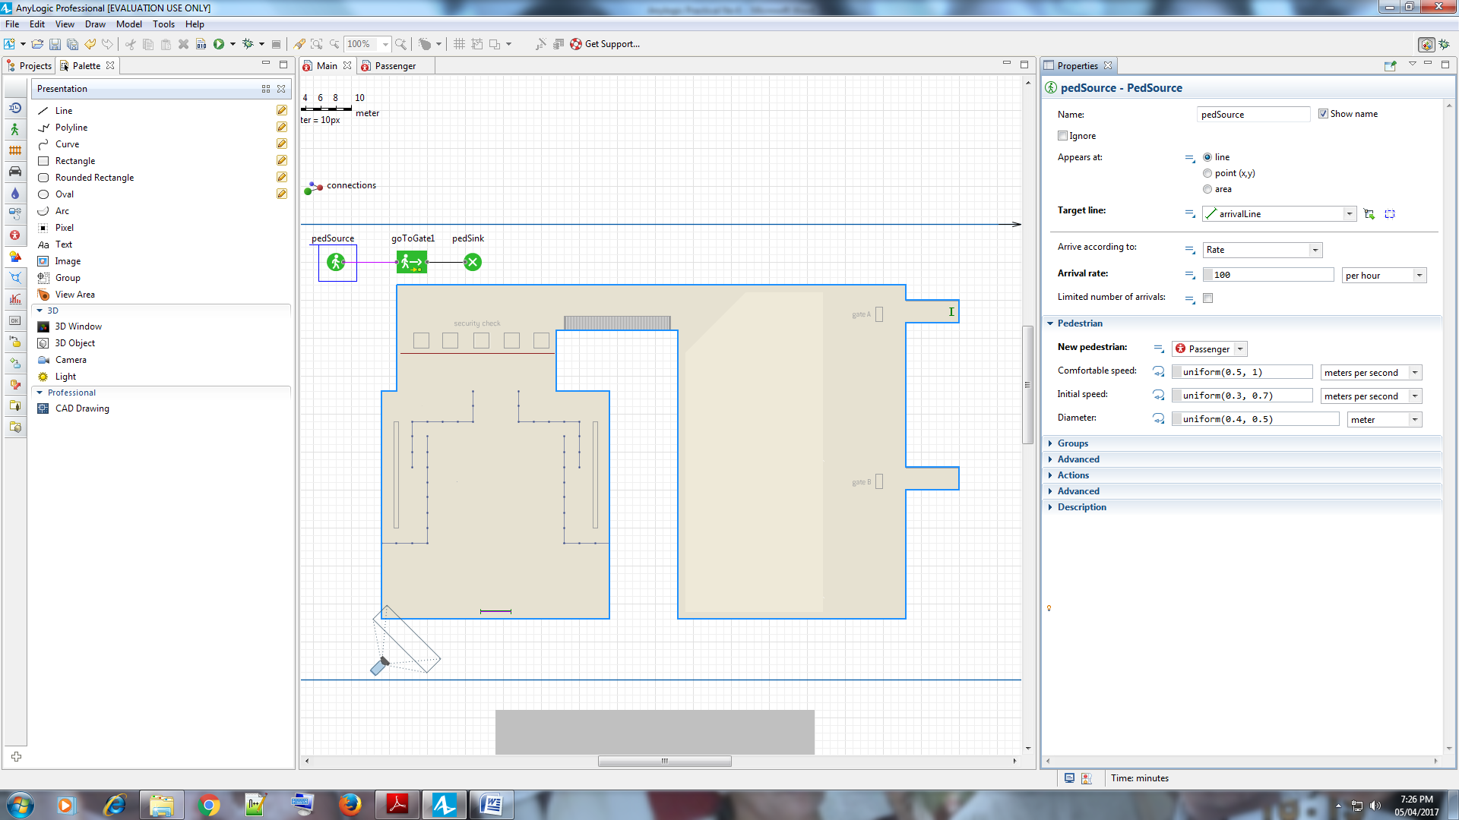

Run the model, and you’ll see pedestrians move from the entry to the gate

inside the building. You can switch to a 3D view by clicking the toolbar’s

**Navigate to view area…** button and then selecting **[window3d]** from the list.

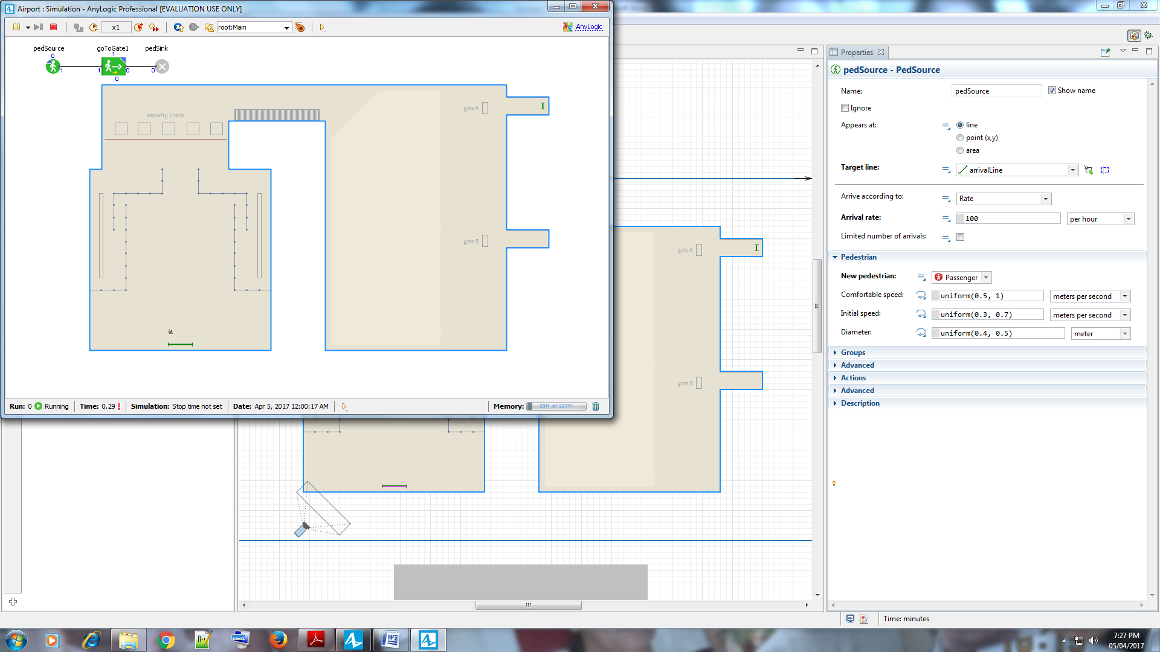

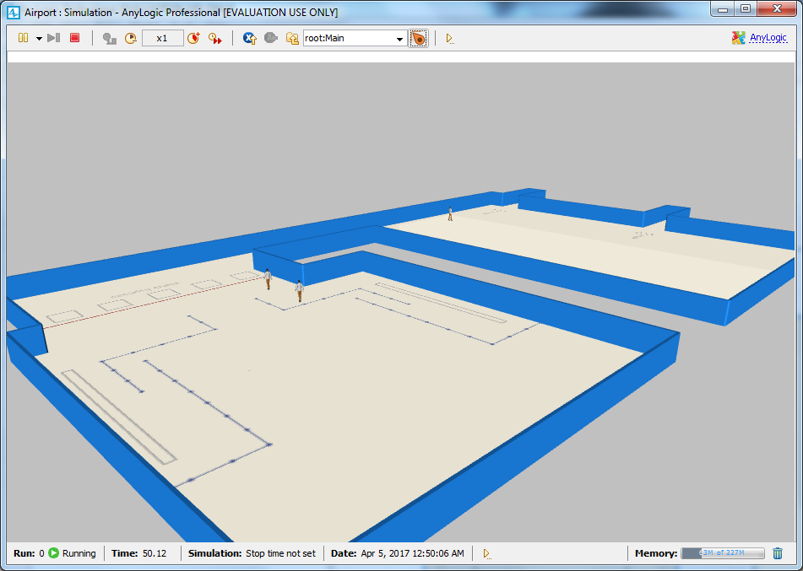

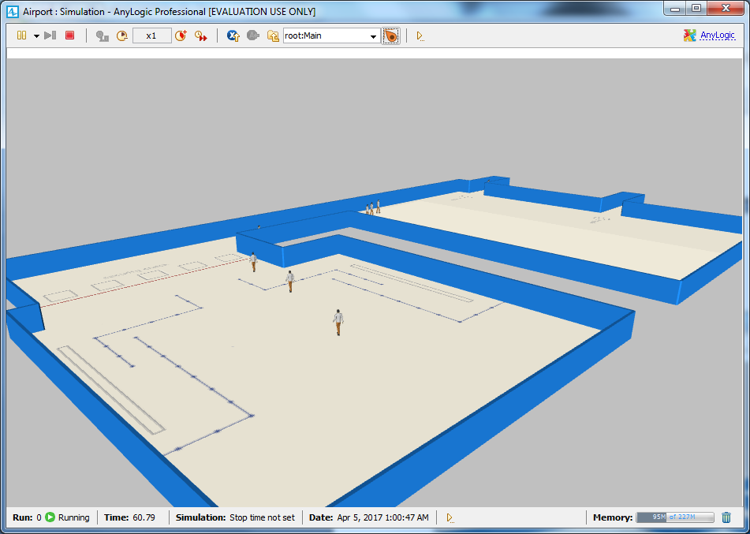

Navigate the scene to get the best view, right-click

inside the 3D scene, and then click **Copy the camera’s location**.

Close the model’s window, open the camera’s properties, and then apply the

optimal camera you selected during the previous step by clicking **Paste**

**coordinates from clipboard**.

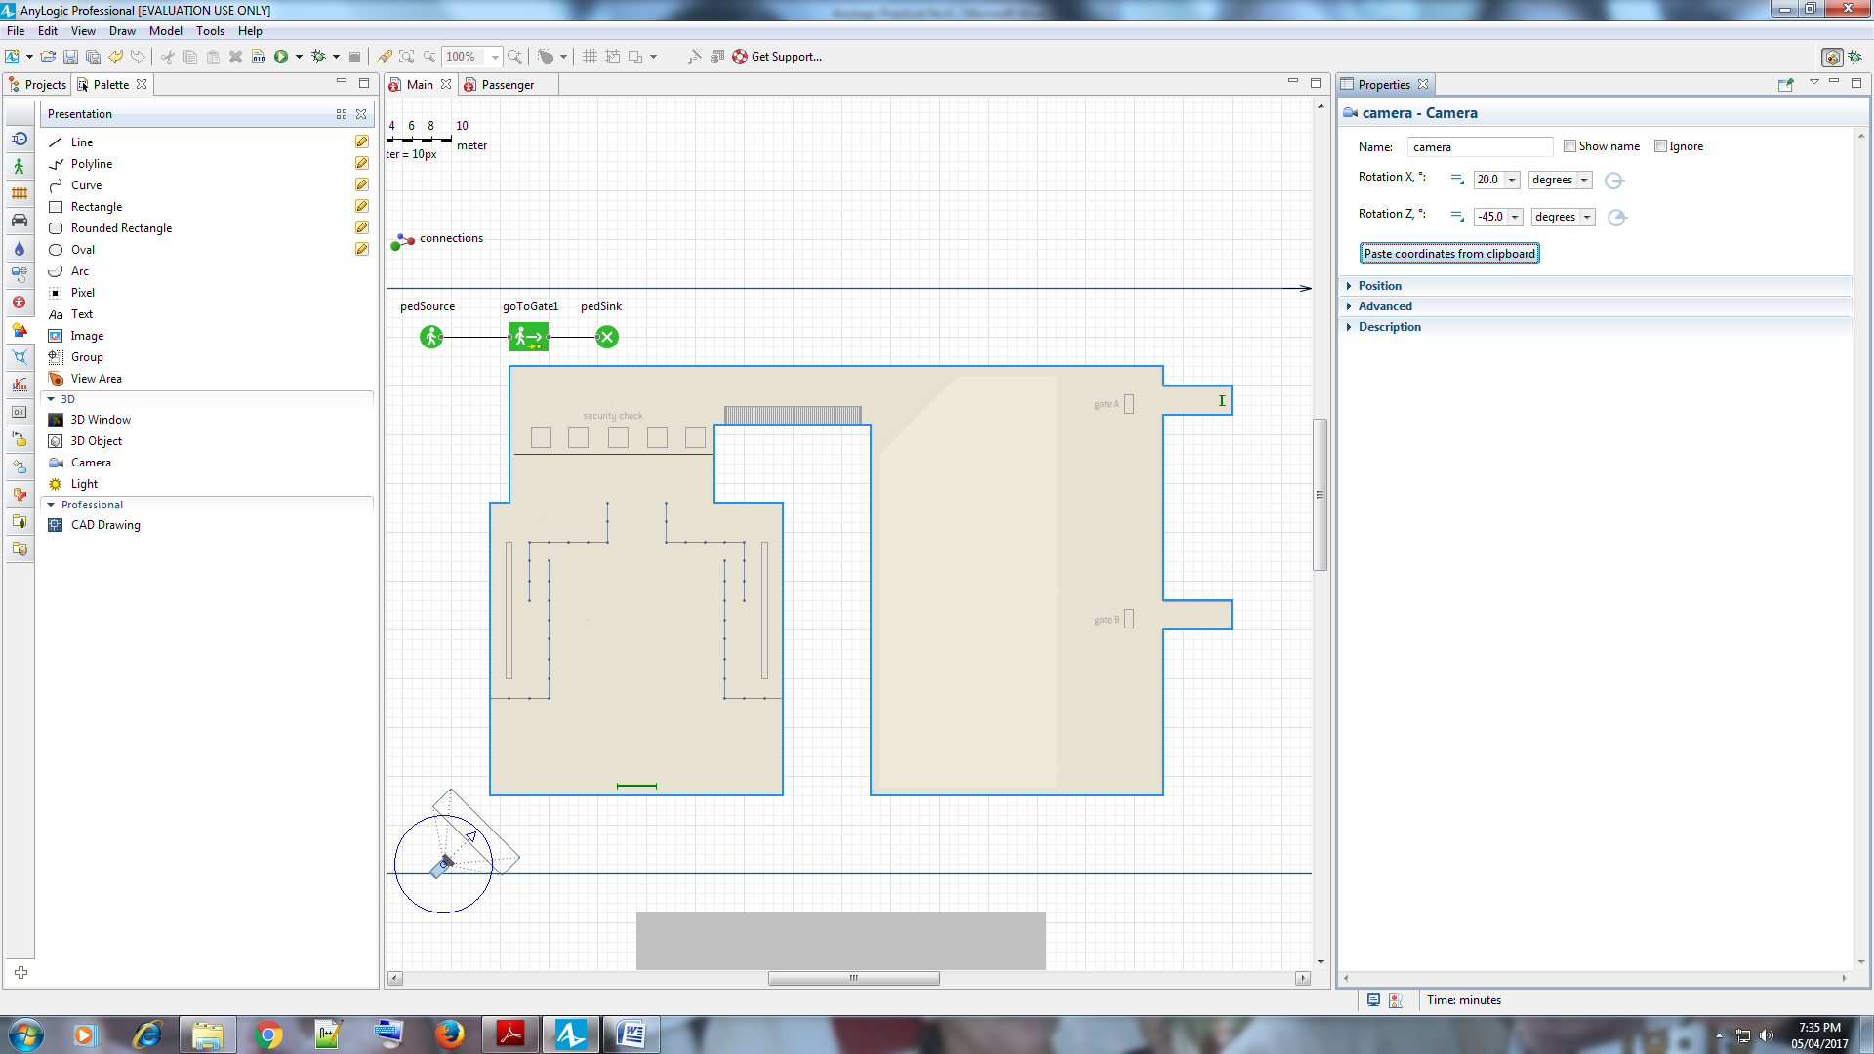

Run the model a second time and view the 3D view that the new camera

position provides.

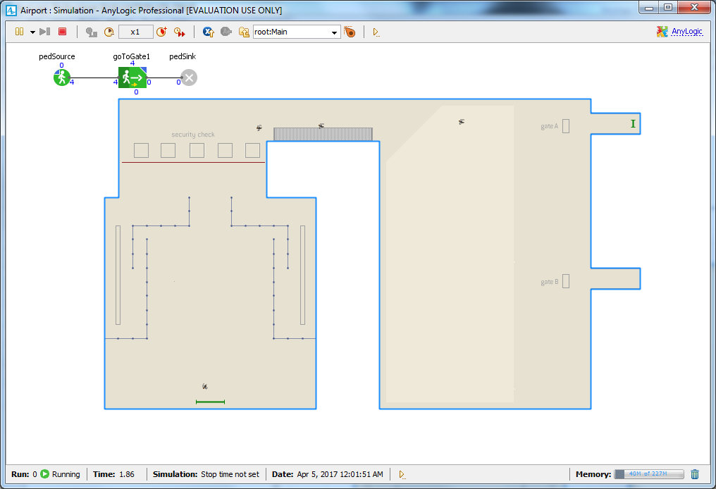

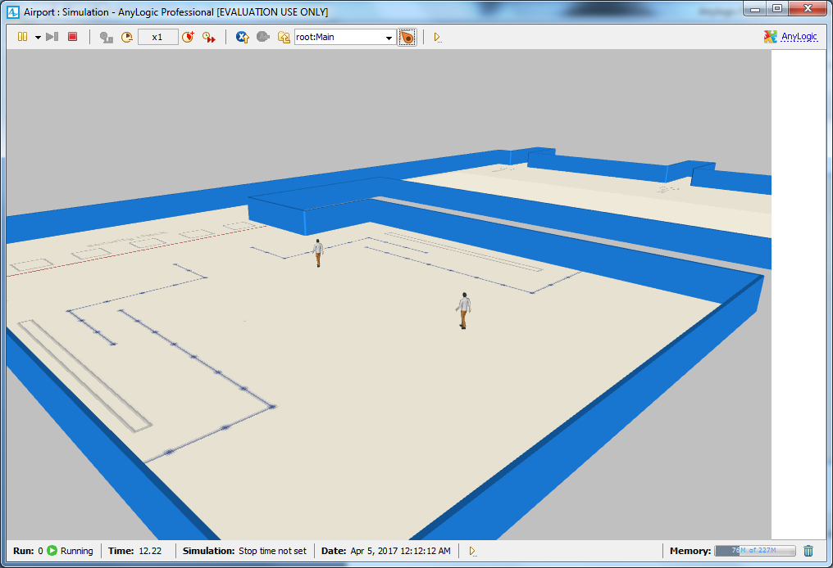

**Adding security checkpoints**

Drag the **Service with Lines** element from the **Pedestrian Library** palette on

to the terminal layout. By default, a service will have two service points and

two queue lines that lead to the service points.

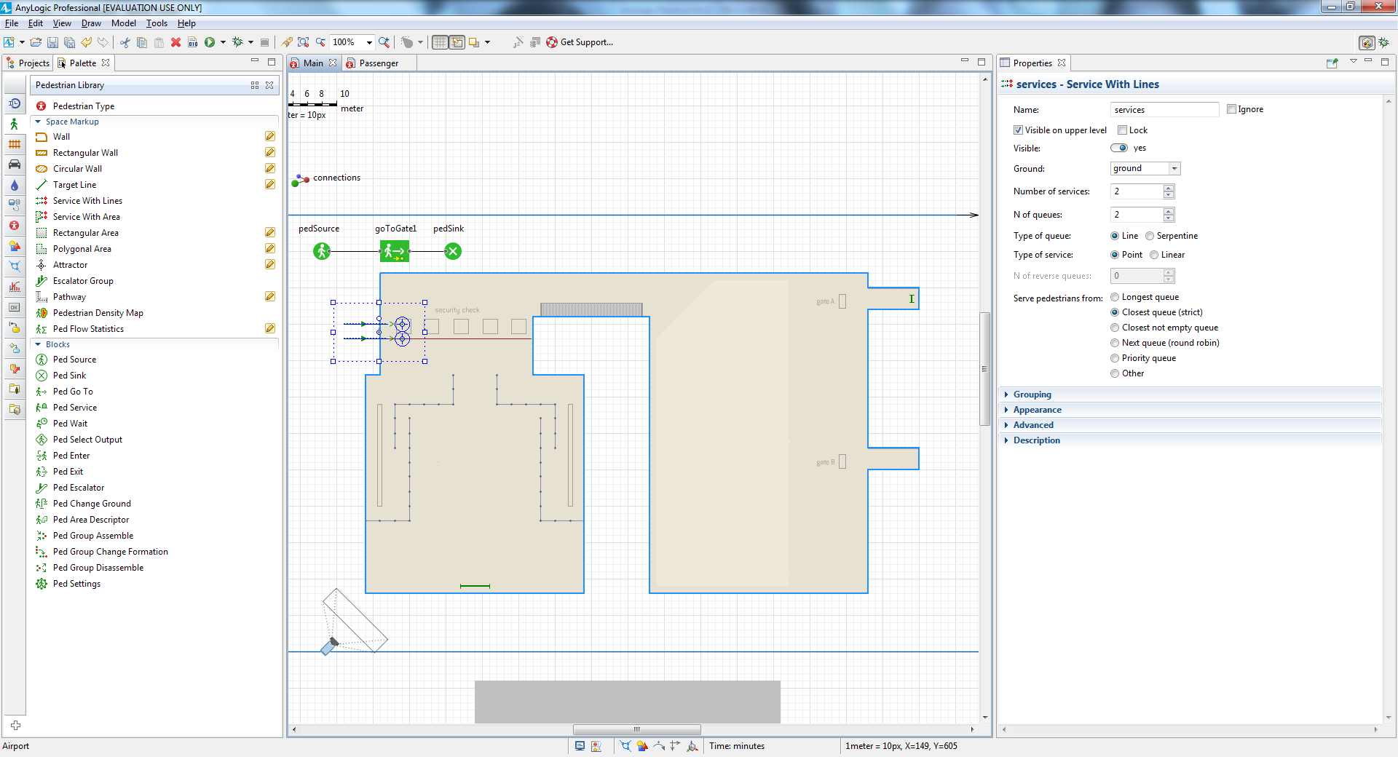

Open the **Service With Lines** properties area, use the **Name** box to name the

shape scpServices - in this case, “scp” stands for security checkpoints - and

then change the **Type of service** to Linear.

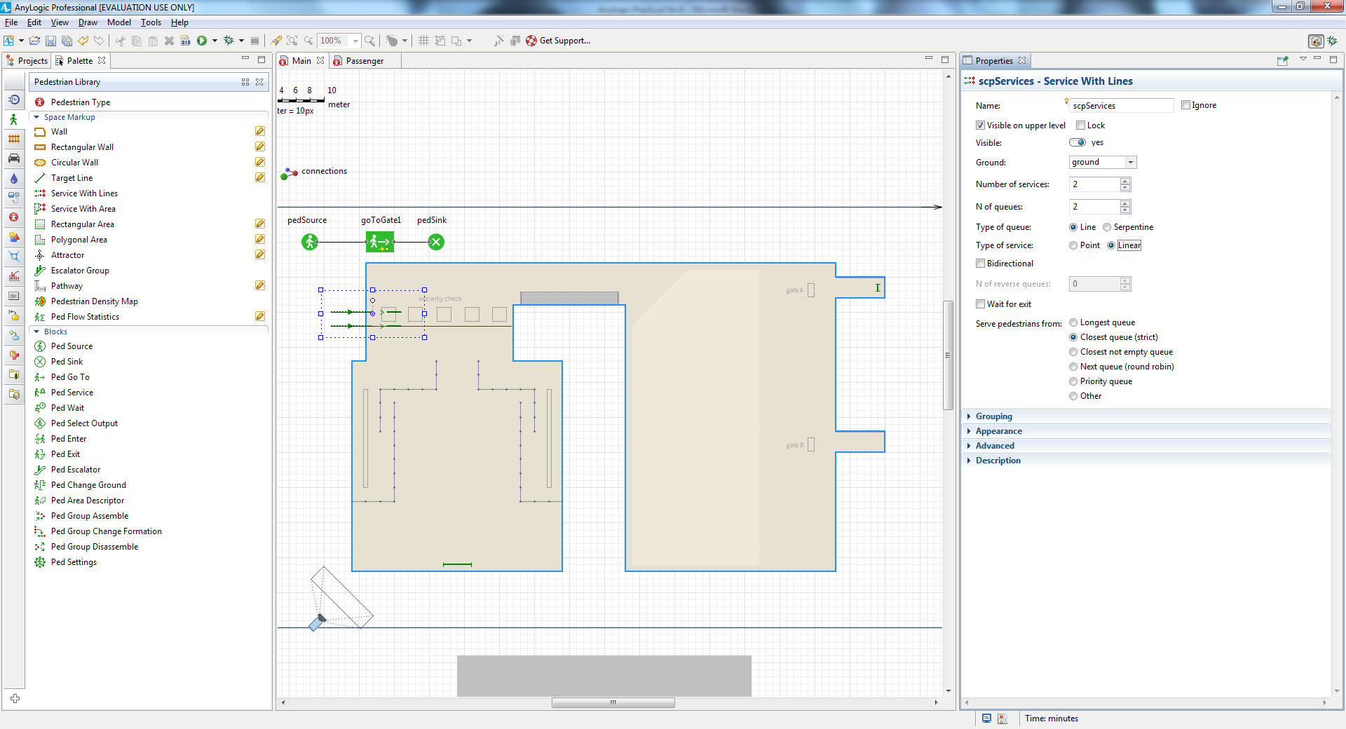

Use the round handle above the shape’s center to rotate the service. So that the arrow points upward

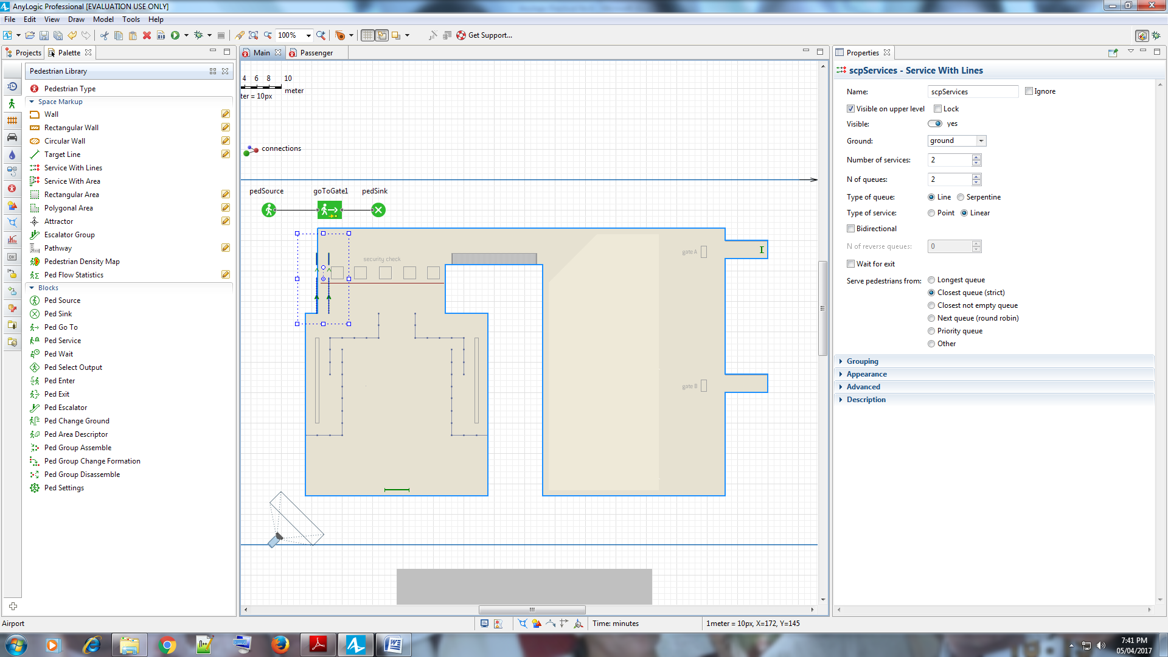

Move the service in a way that ensures the first linear service crosses the

rectangle that represents the metal detector frame.

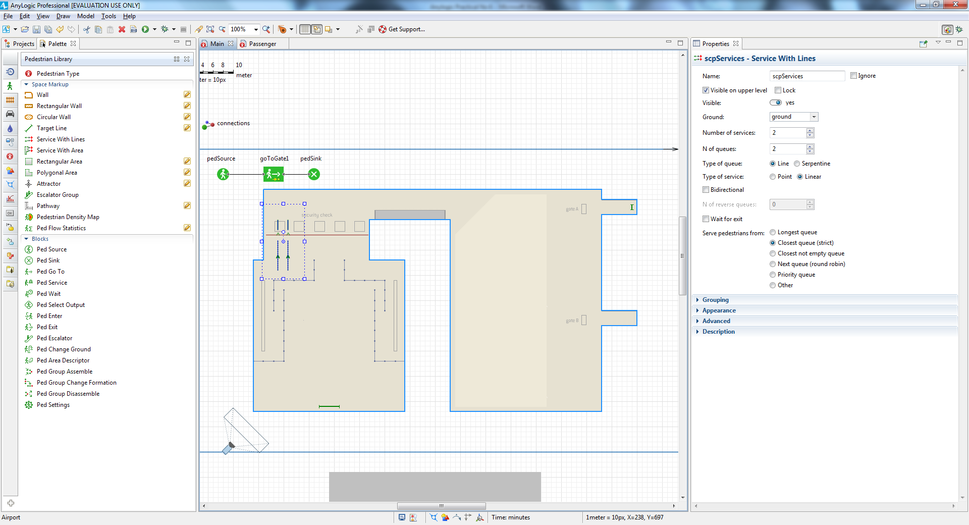

Select the next service line.

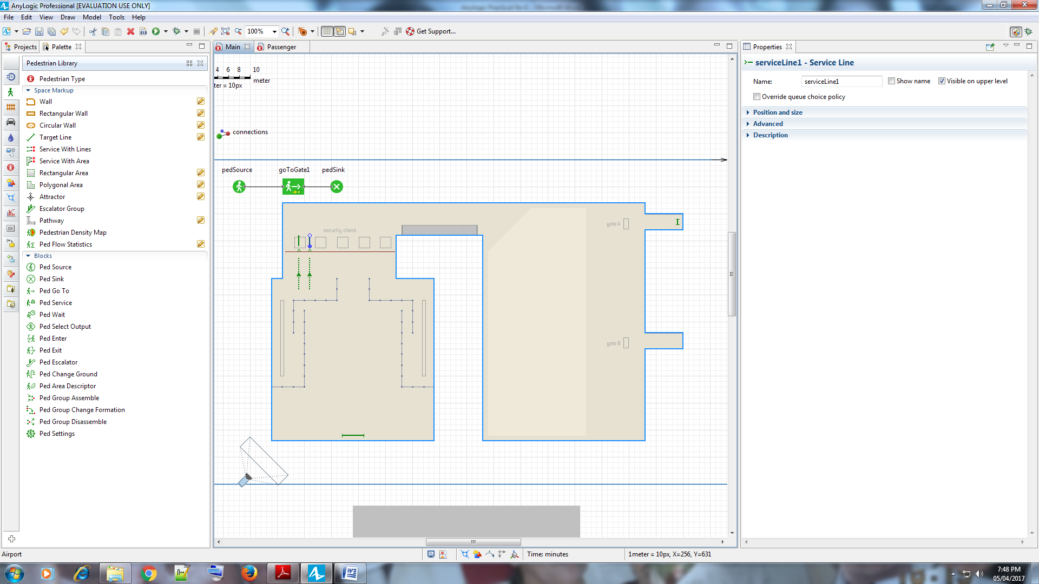

Accurately place the service line on top of the second security checkpoint

placeholder and then adjust the queue location.

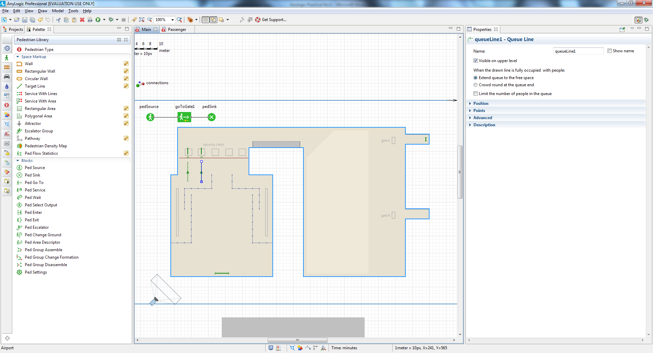

Navigate to the **Service with Lines** shape’s properties and then change both

the **Number of services** and **Number of queue** to 5.

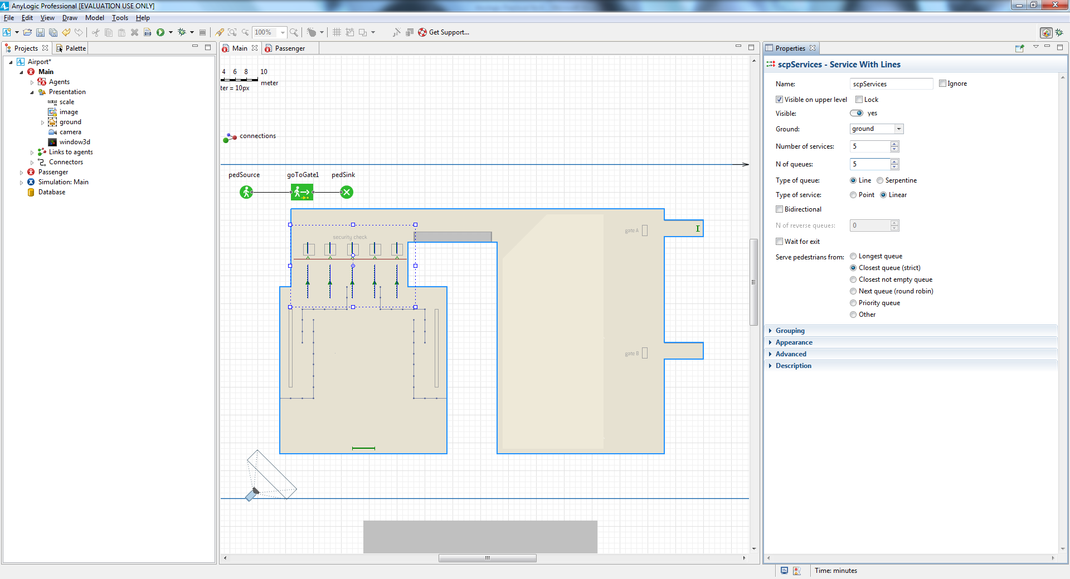

If necessary, adjust the new service and queue lines. After you’ve completed

this step, the service shapes should look like those in the figure below.

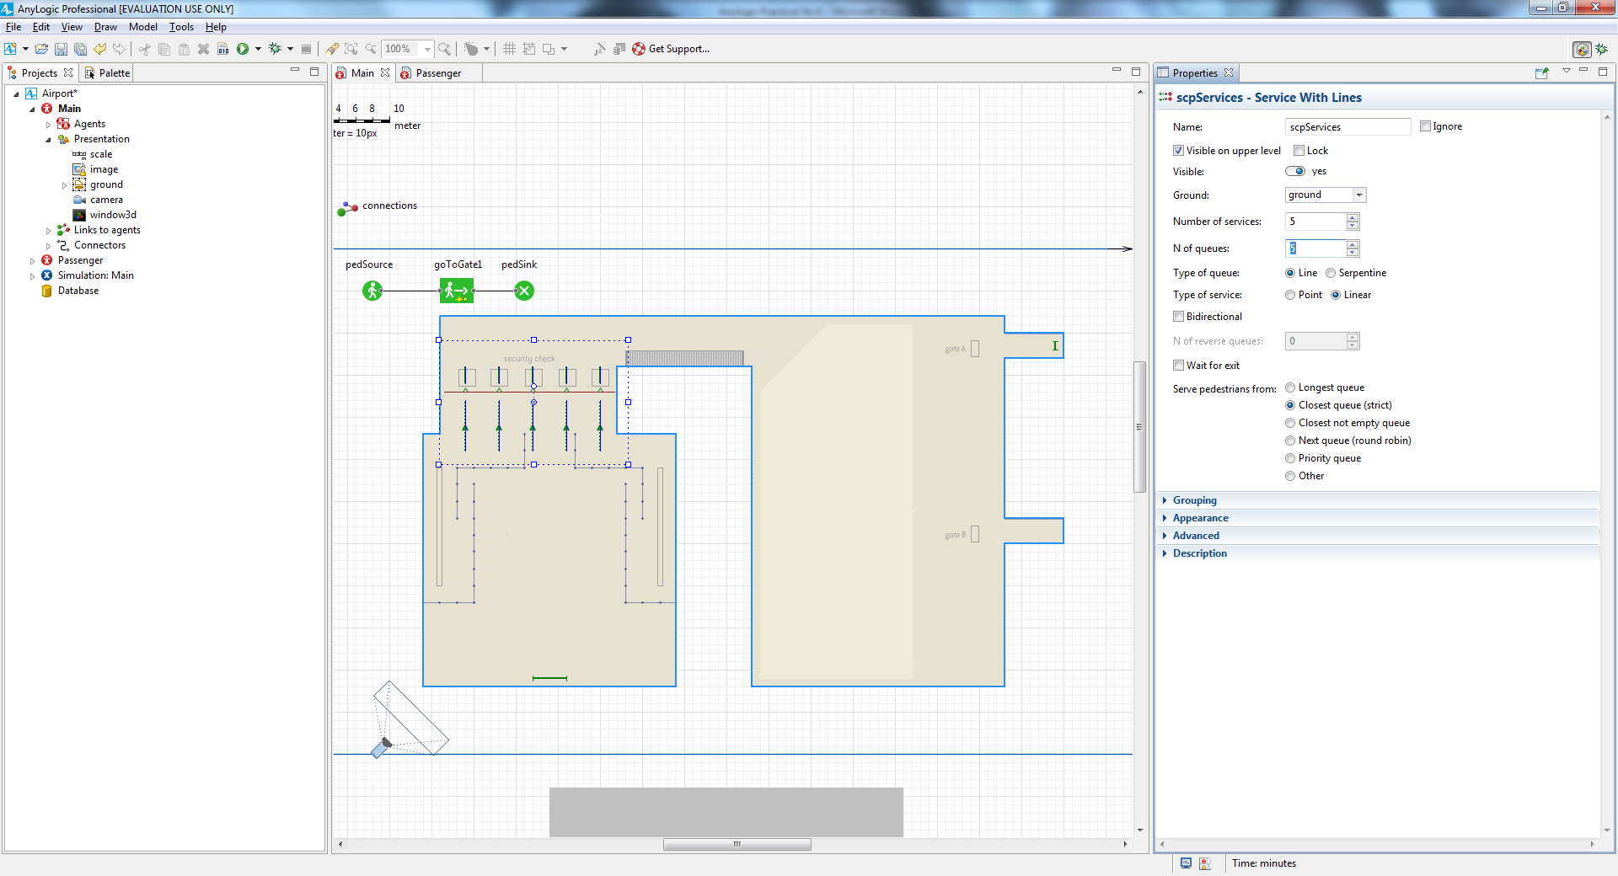

Add the **PedService** block on to the flowchart between the **PedSource** and

**PedGoTo** blocks to make pedestrians pass through the service we defined using the referenced Service with Lines shape, and then name it

securityCheck.

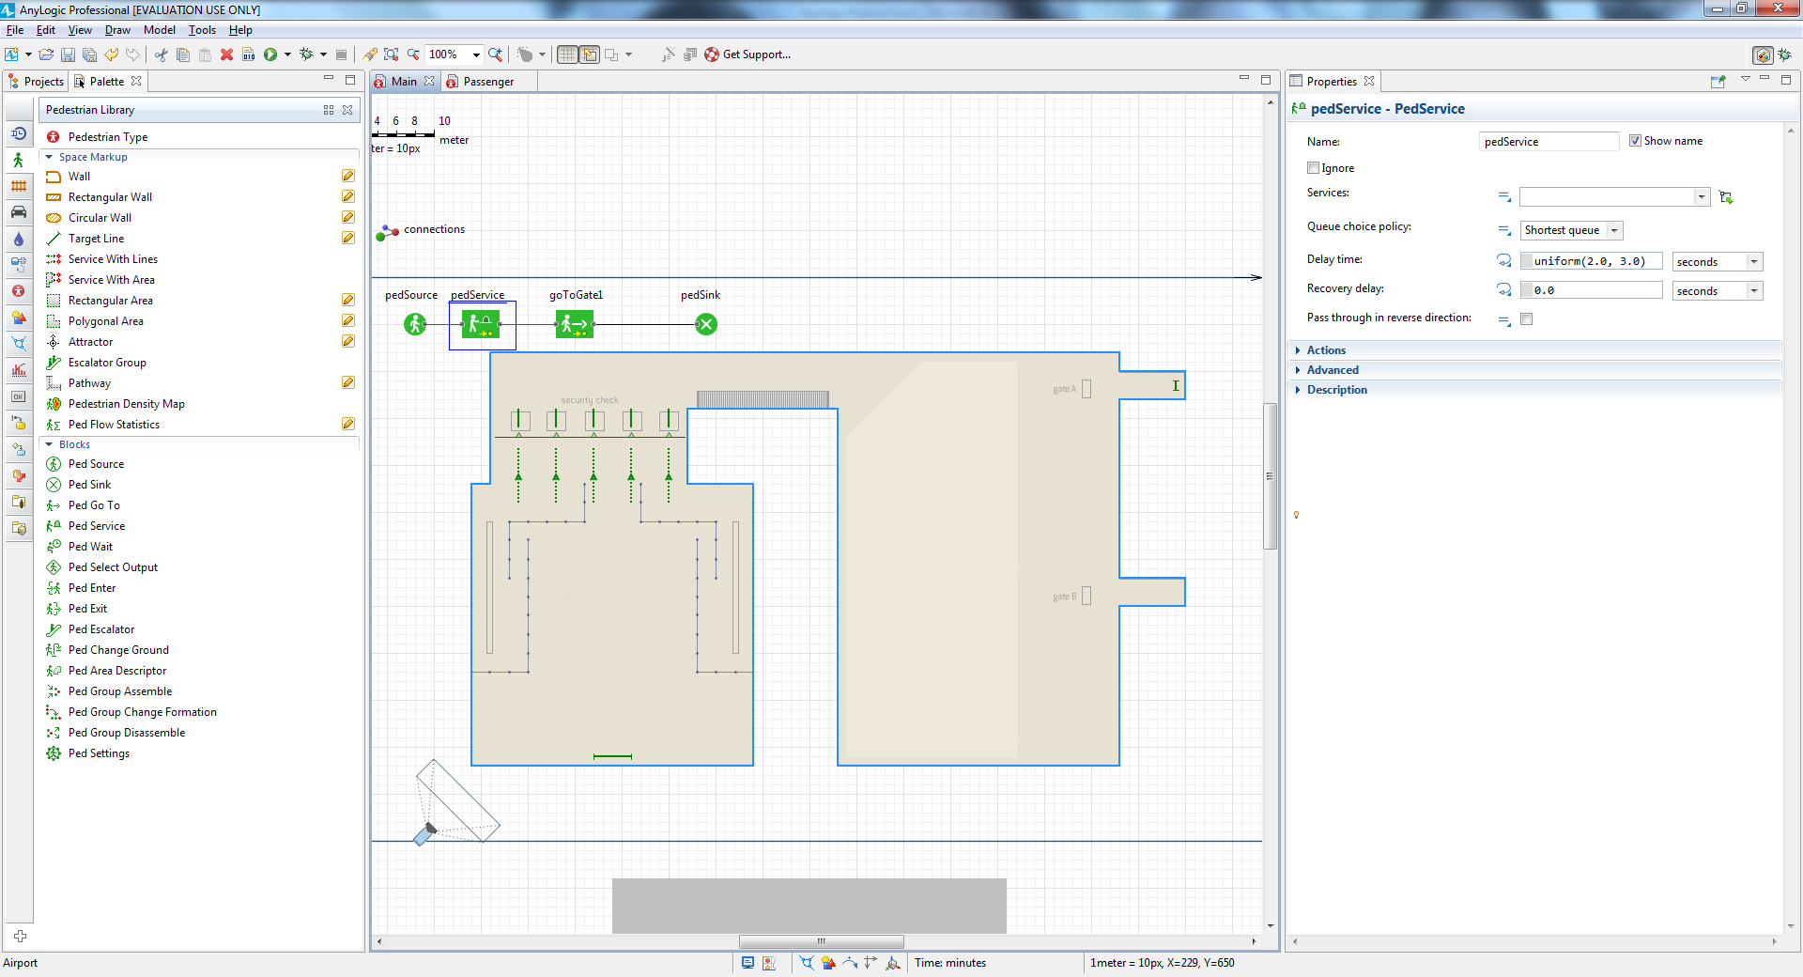

Go to the securityCheck block’s properties. Select the services scpServices as

**Services**.

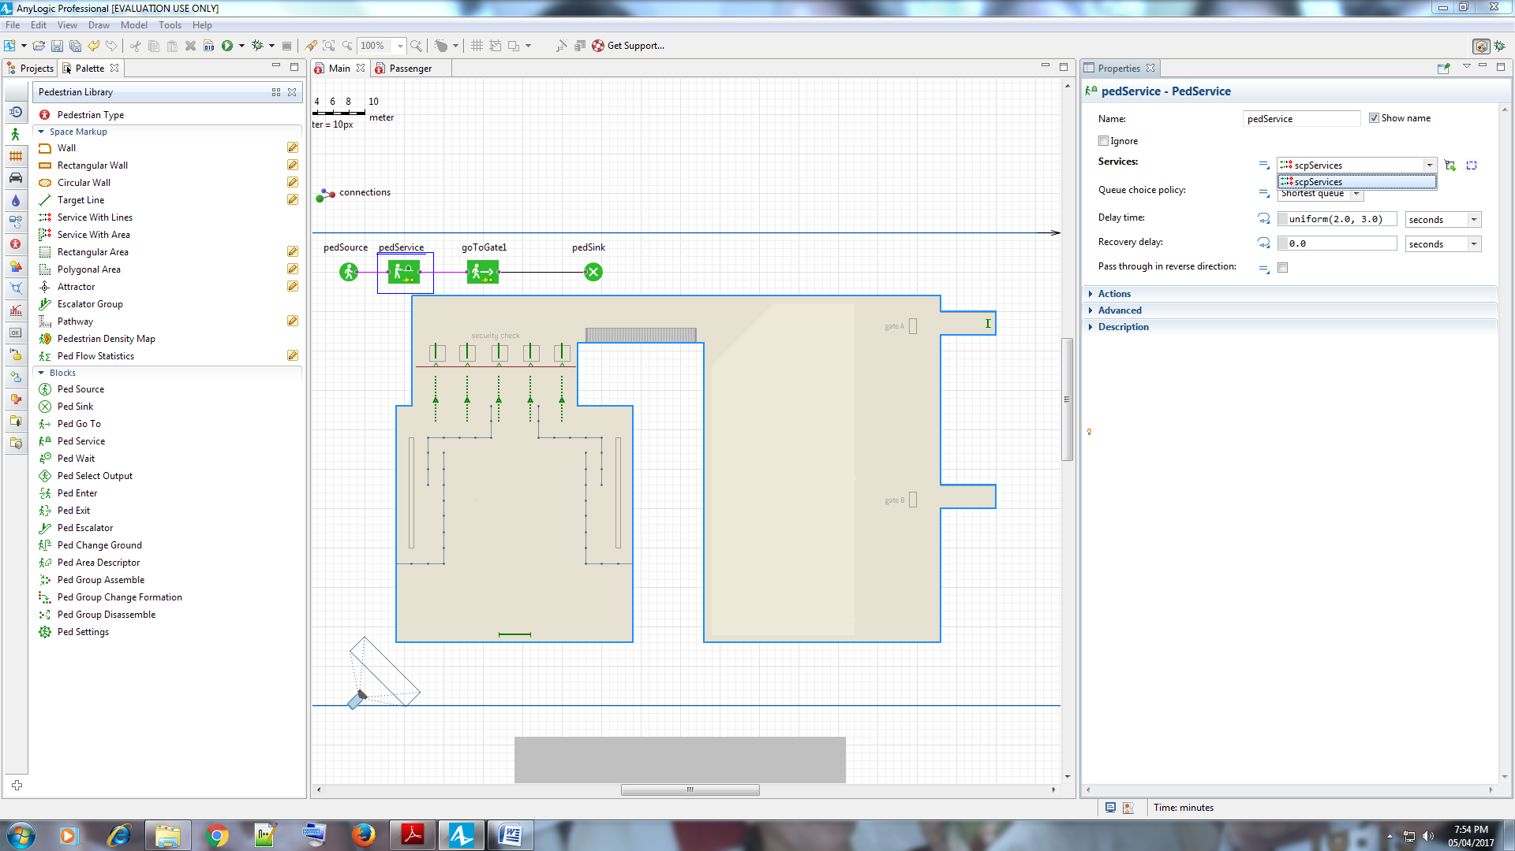

Since we assume it takes between 1 to 2 minutes to pass through the security

checkpoint, type uniform(1, 2) **minutes** as the **Delay time**.

Now let’s add 3D models of the security checkpoints. Using the **3D Objects**

palette, **Airport** section’s Metal Detector and XRay Scanner elements, draw

five security checkpoints. You will see the message box, prompting you to

change the scale of 3D object. Select the option **Do not ask me again** and click

**OK**.

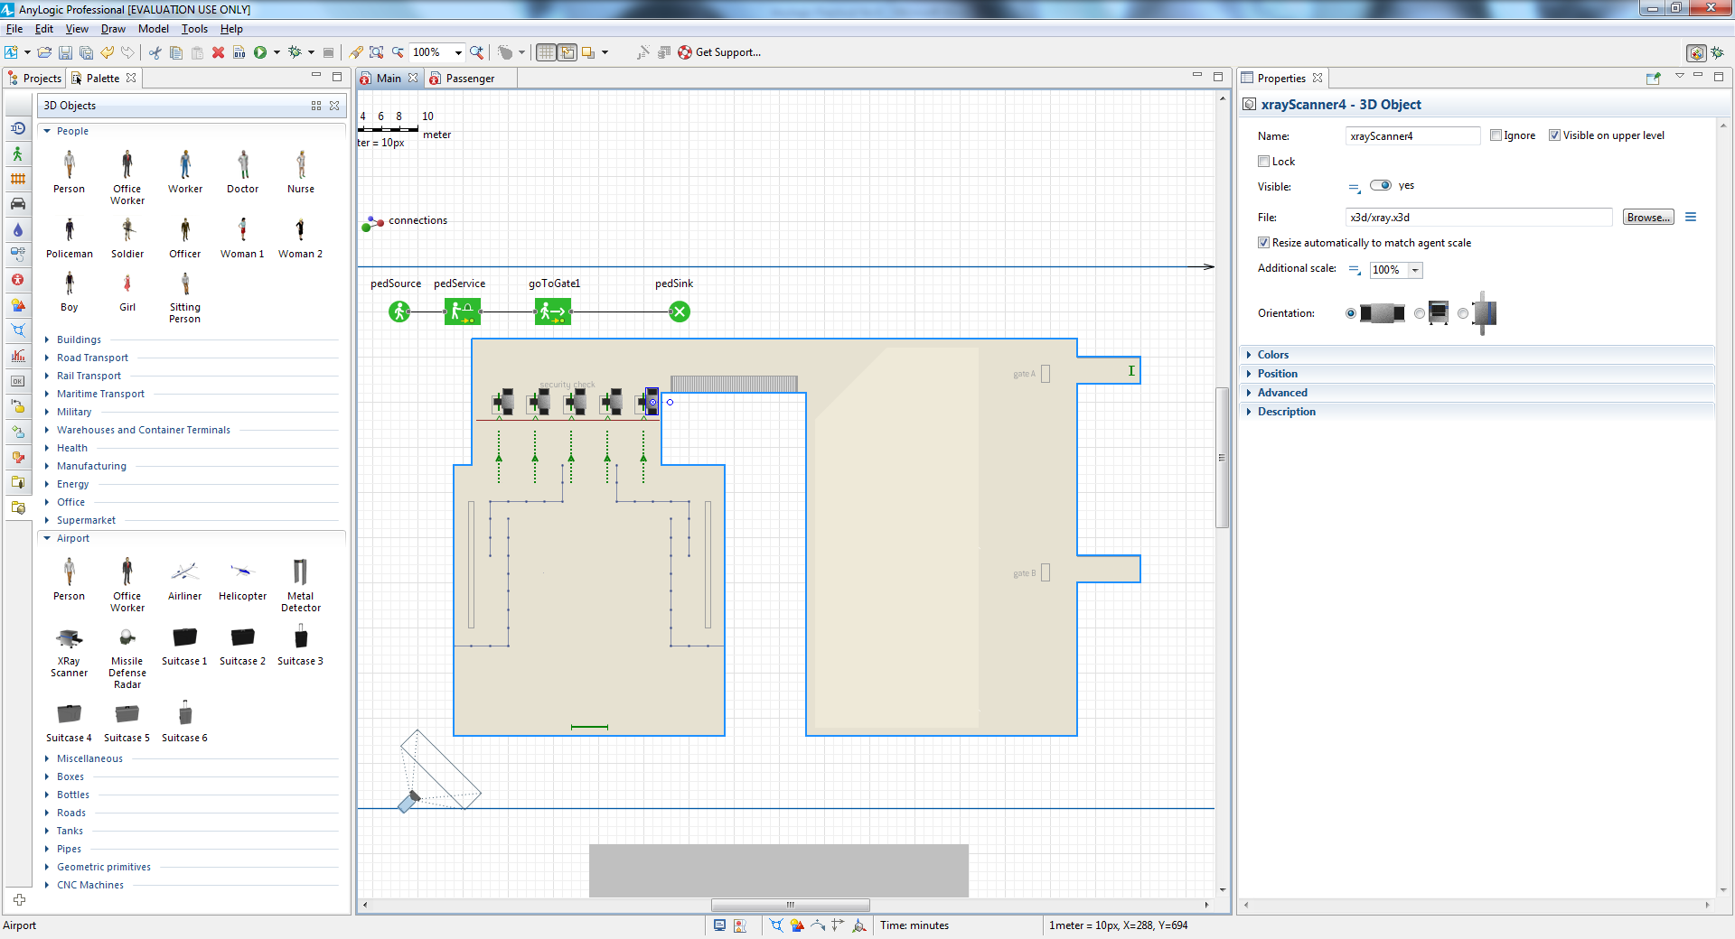

Run the model. You’ll see that passengers are now scanned at the security

checkpoints.

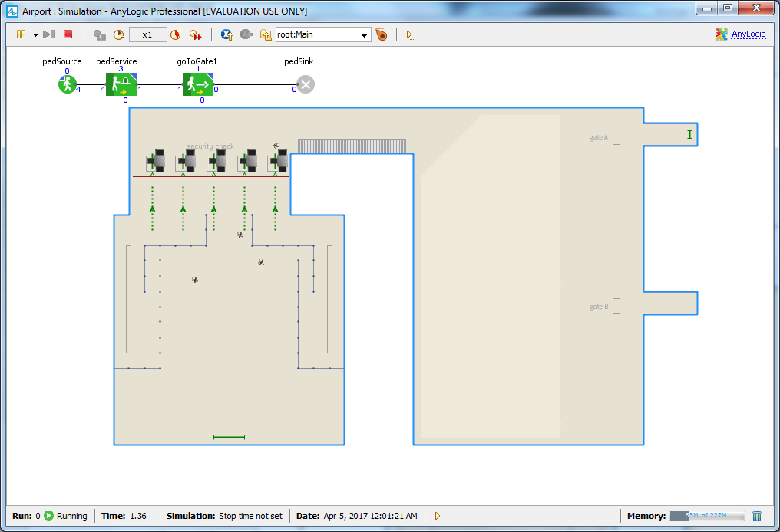

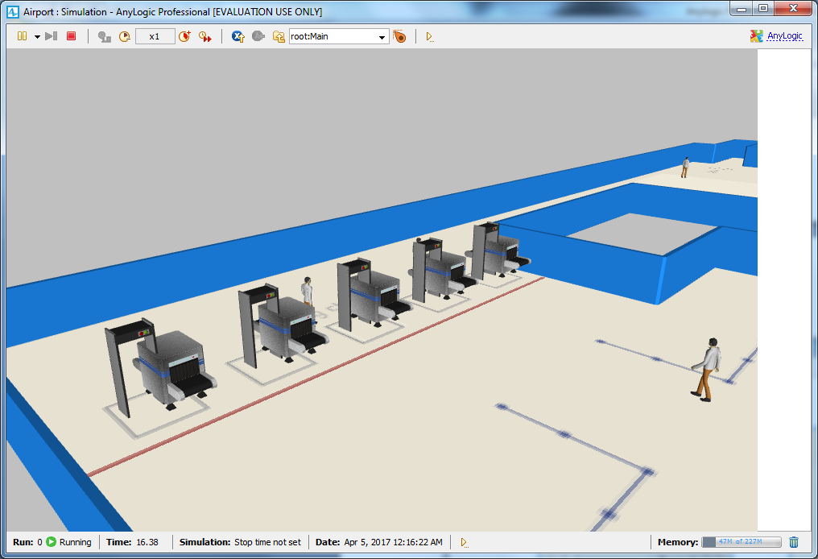

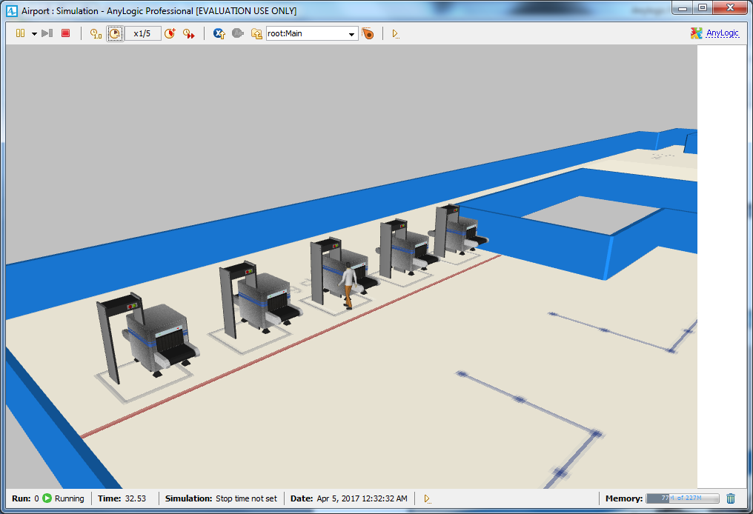

**Adding check-in facilities**

Draw check-in locations with another **Service with Lines** shape. Rotate it so that the arrow points towards left.

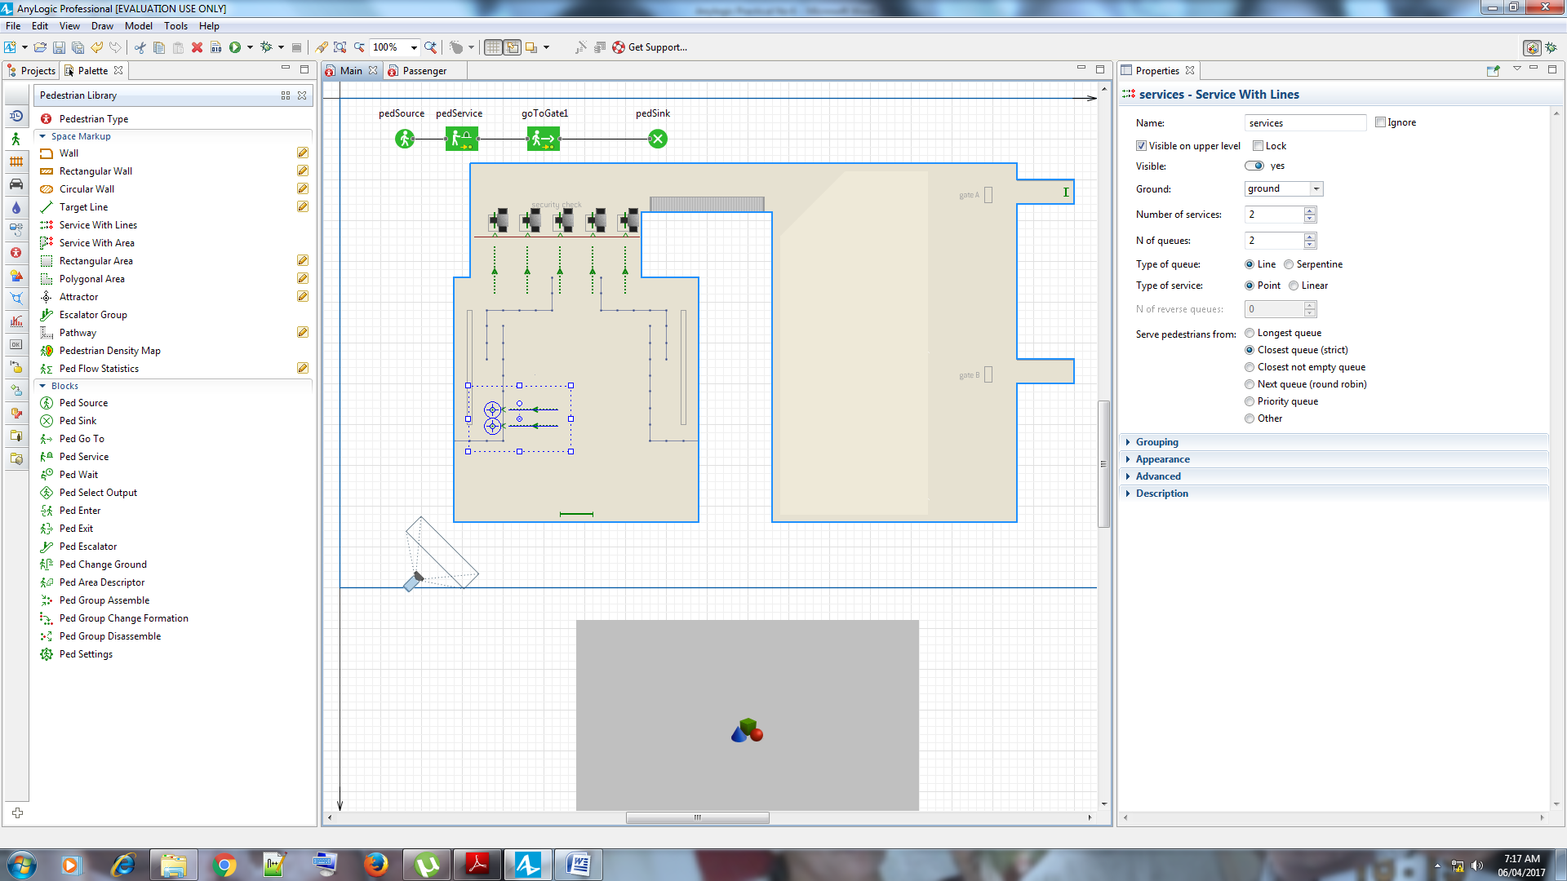

Navigate to the **Service with Lines** shape’s properties and then change both

the **Number of services** and **Number of lines** to 4.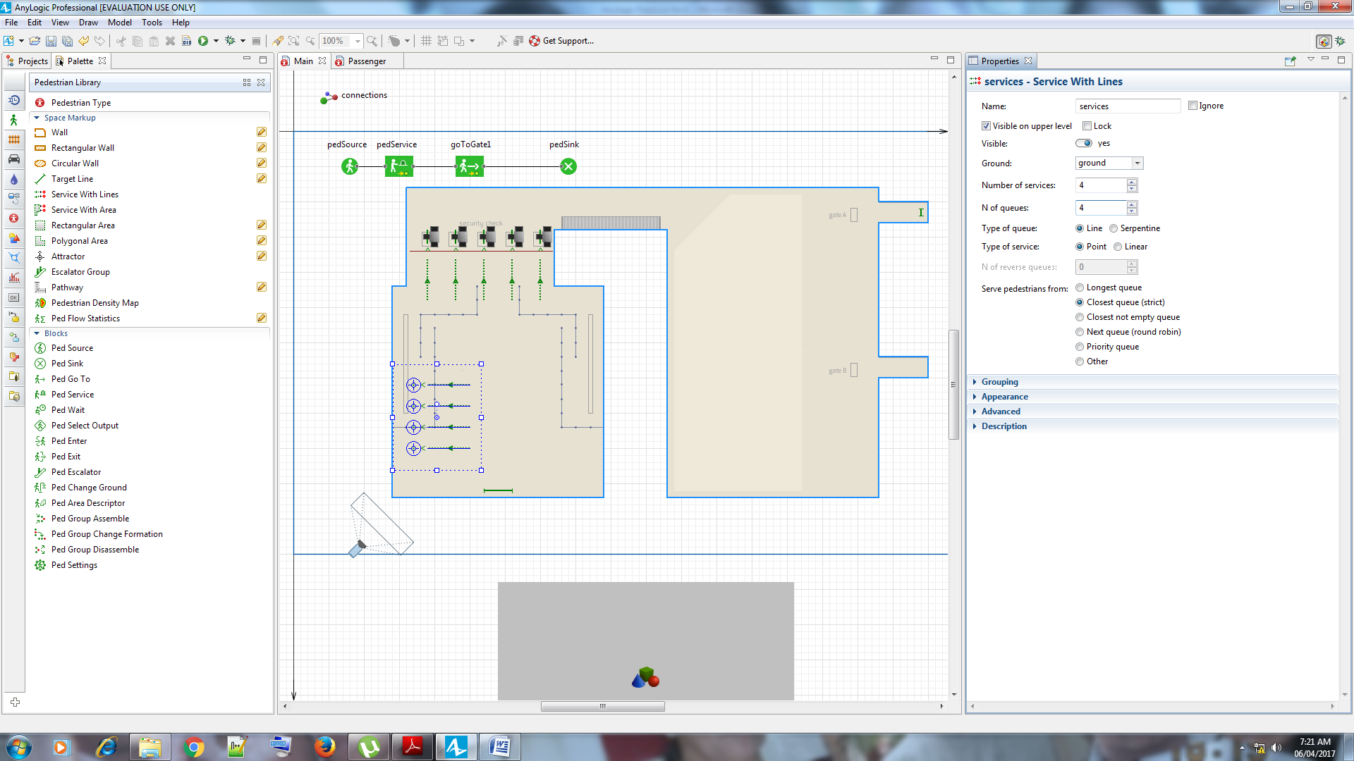

Name the services checkInServices. Place the shape in the location shown in

the figure below

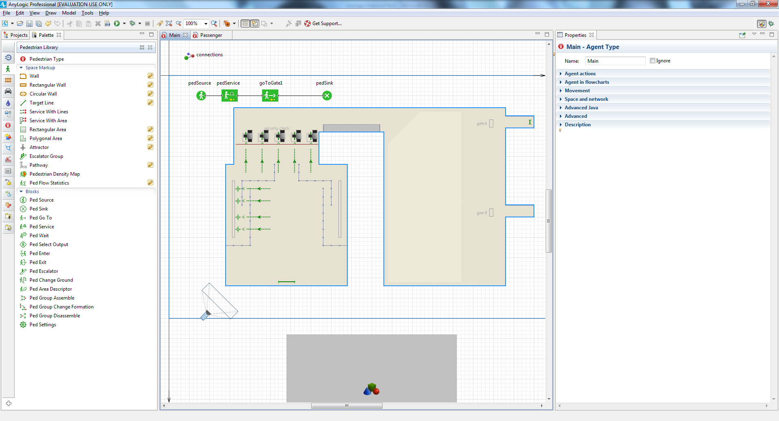

Add more salient points to the line. Right-click the queue line and choose **Add**

**points** from the pop-up menu. Add more points by clicking where you want to

place the line’s salient points. Finish drawing the line by double-clicking.

Finally you should get the queue line of the following form

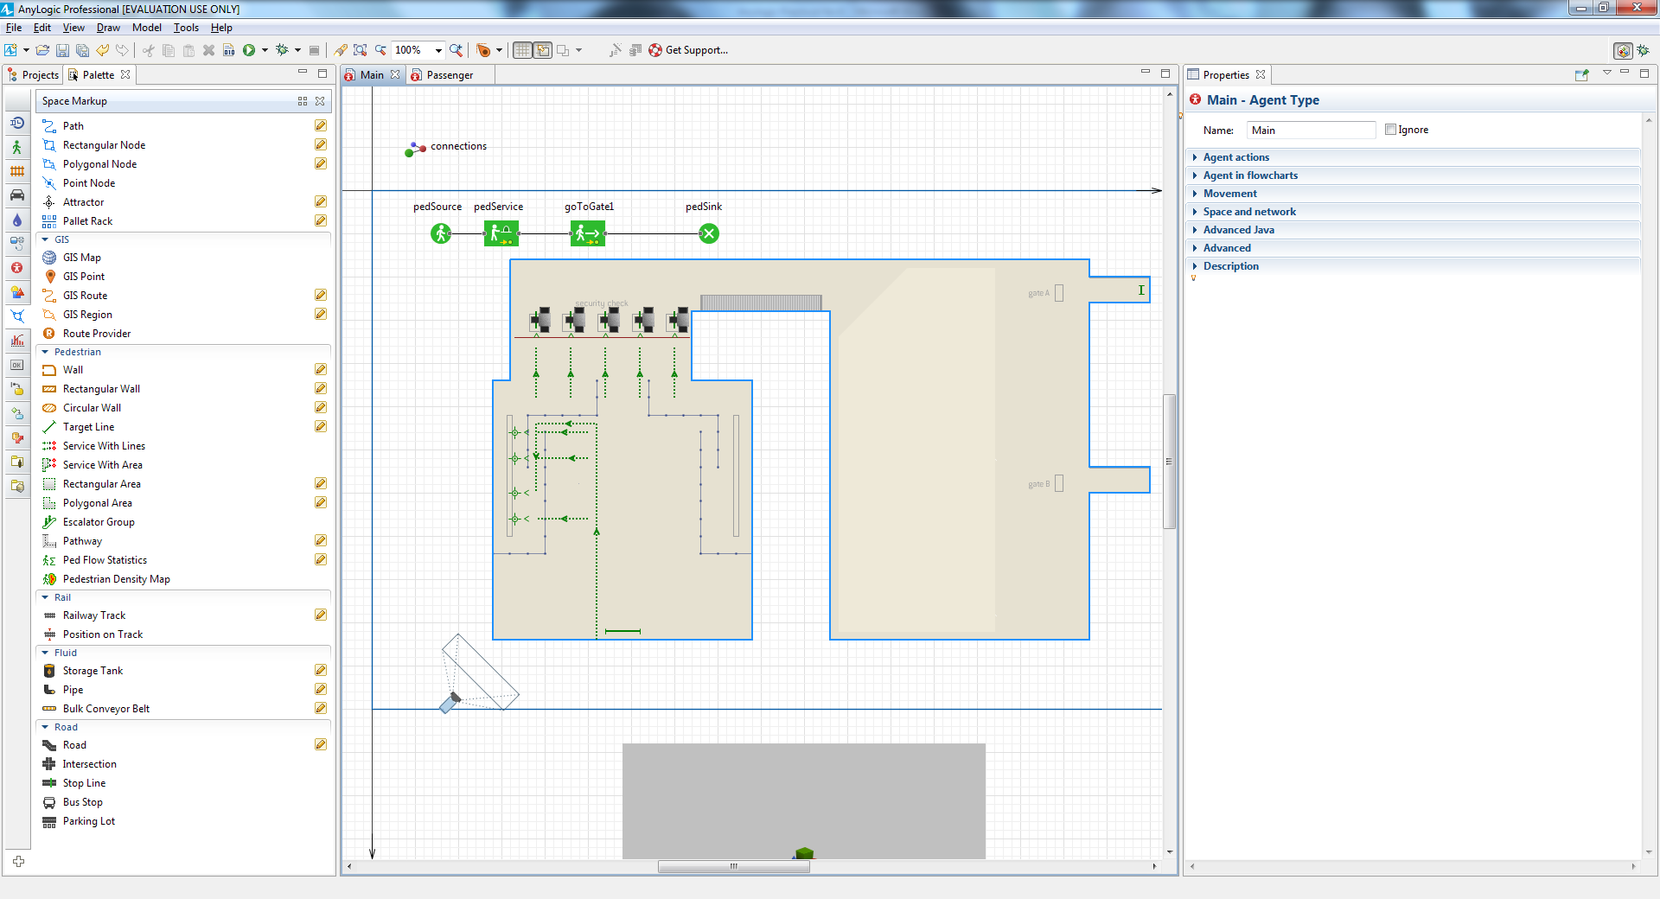

In the properties of this **Service with Lines** shape, change the **Type of queue** to

**Serpentine**. Use this option to simulate serpentine (also named "zigzag")

queues. You will see that the queue has borders now. In 3D animation they

will appear as belt barriers.

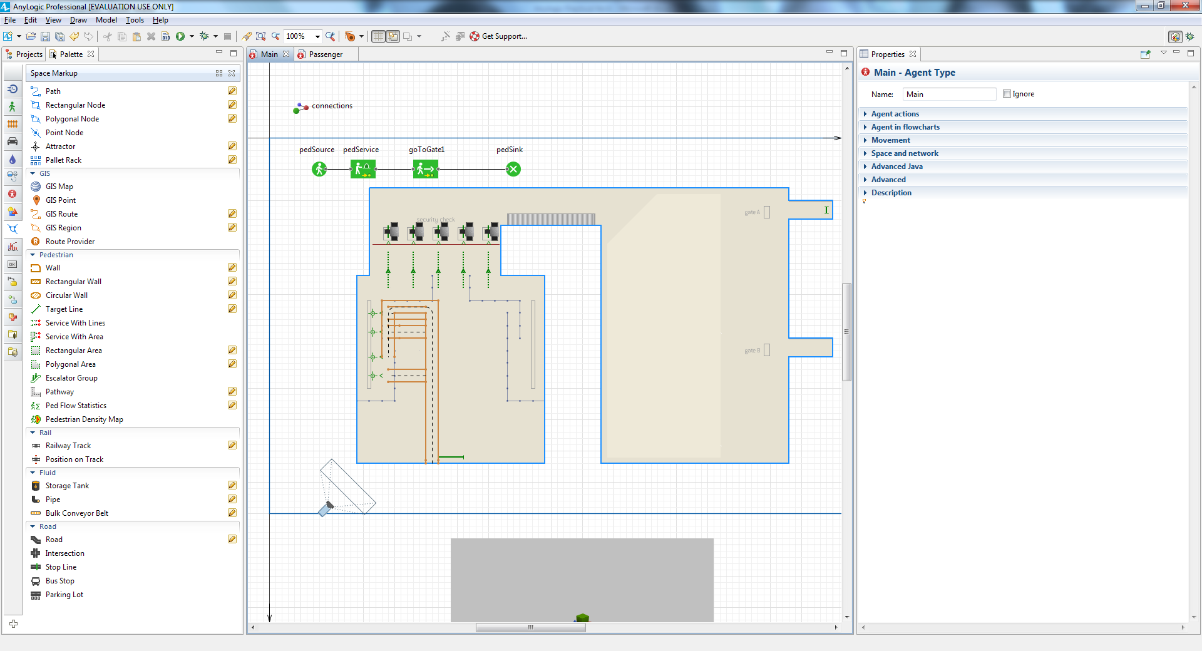

Add another **PedService** block and name it checkInAtCounter

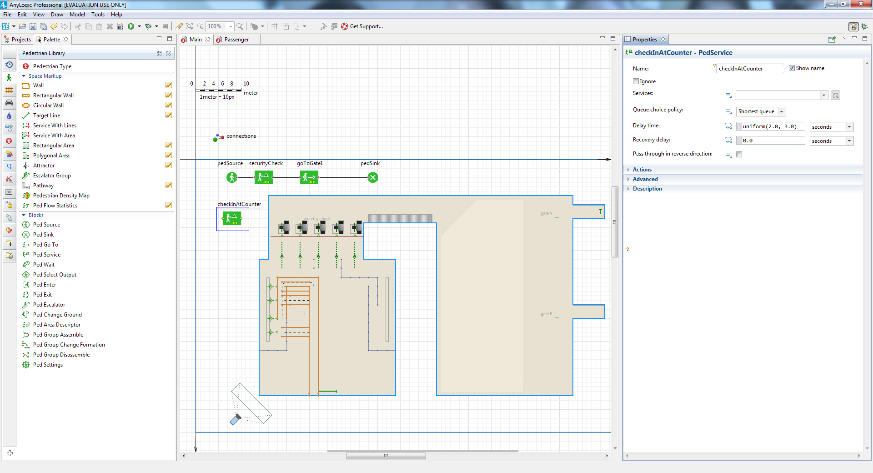

In the block’s properties, select the space markup shape checkInServices as

**Services**.

Since we assume it takes between 2 to 4 minutes to check in, type

uniform(2, 4) **minutes** as the **Delay time**.

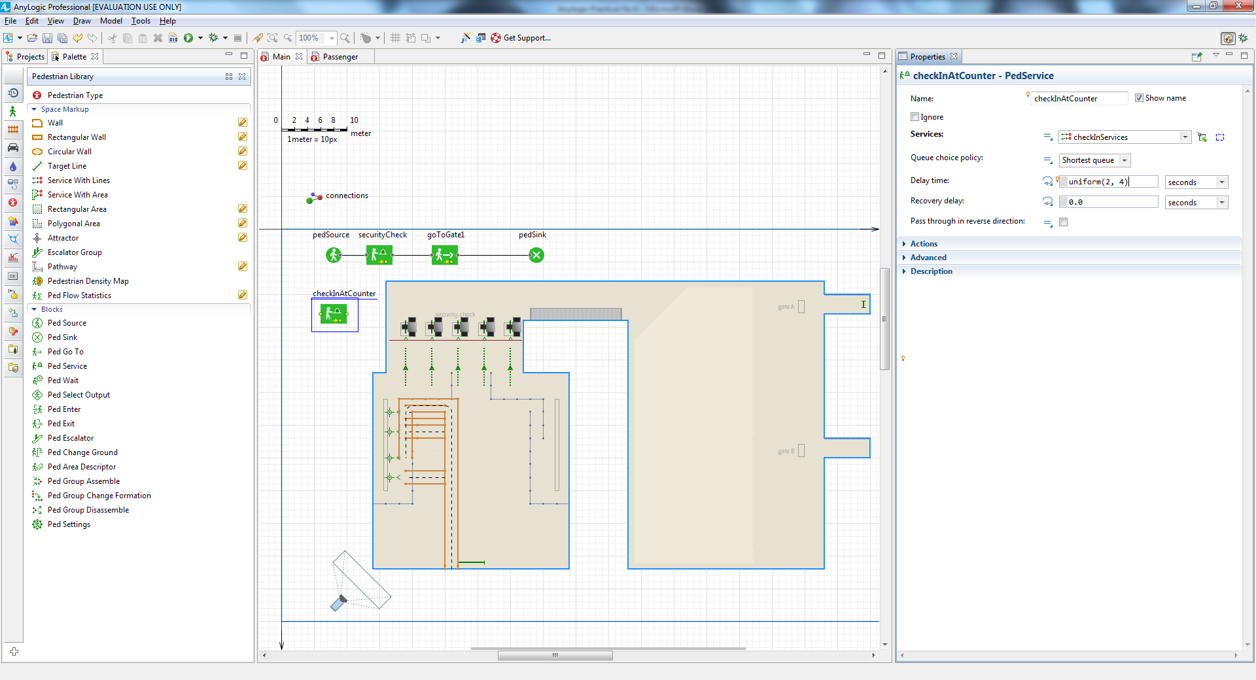

Add the **PedSelectOutput** block to route passengers to different flowchart

branches.

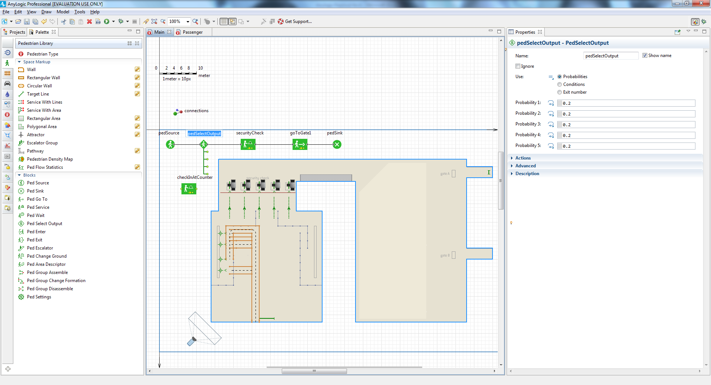

Connect the checkInAtCounter block to the existing flowchart blocks as shown

in the figure below.

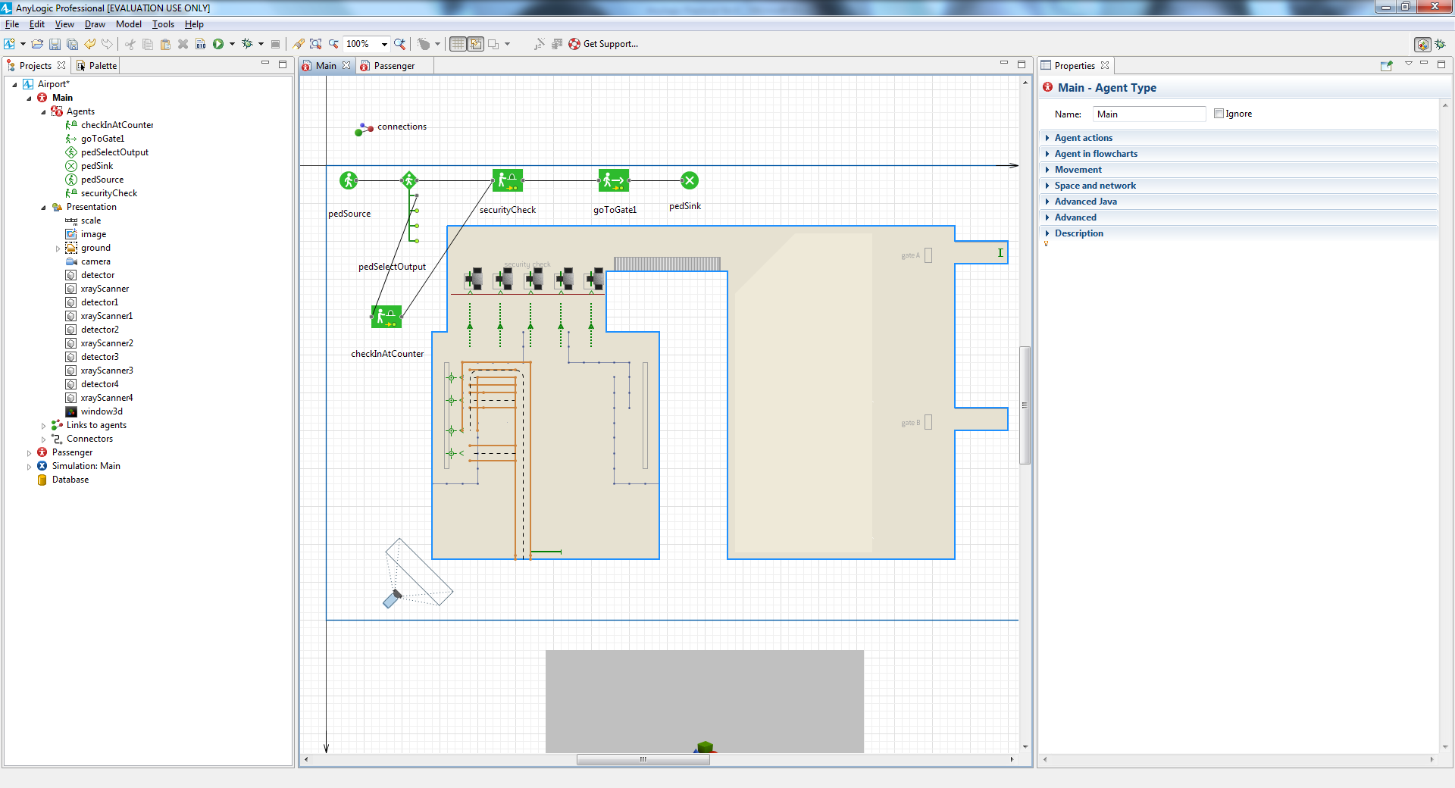

Since we’re assuming 30 percent of our passengers will check in online and

70 percent will check in at the counter, we’ll model this behavior by setting

pedSelectOutput’s **Probability 1**: to 0.3 and **Probability 2**: to 0.7. This action

will route 30 percent of the passengers to the upper flowchart branch and 70

AnyLogic 7 in Three Days **219**

percent of the passengers to the lower branch. You must set **Probability 3**,

**Probability 4**, and **Probability 5** to 0 to prevent AnyLogic from routing

passengers to the block’s lower three output ports.

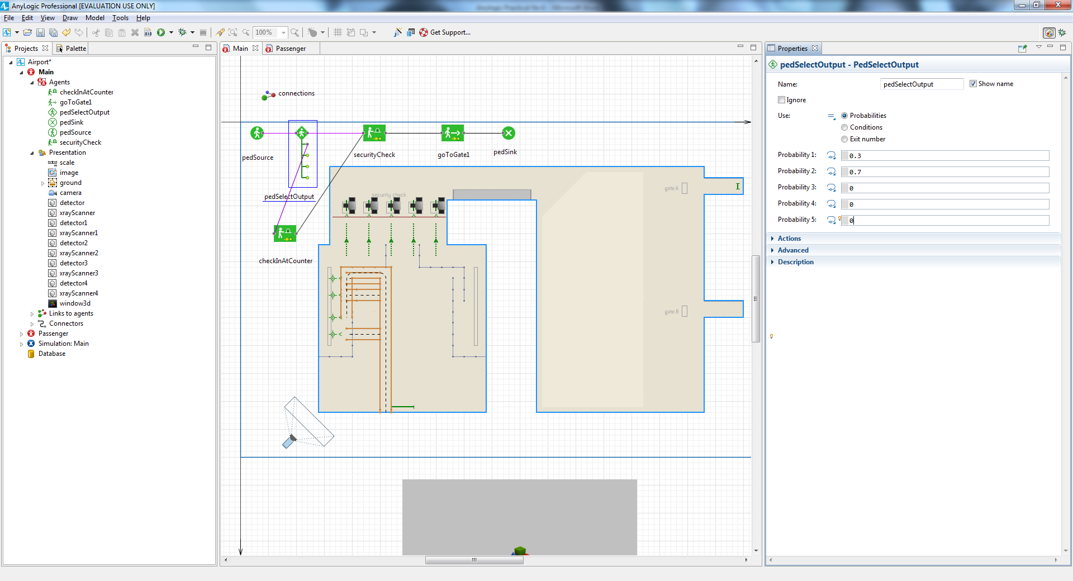

Let’s add ready-to-use 3D models to the airport’s check-in area. On the

Palette's **3D Objects** tab, expand the **People** section, and then add two copies

of both Office Worker and Woman 2. to the diagram. As shown below

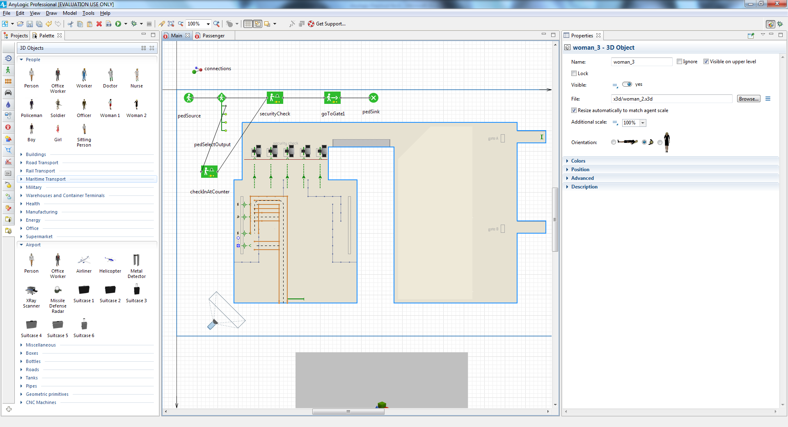

Define the area that is not accessible by passengers. Add the **Rectangular Wall**

element from the **Space markup** section of the **Pedestrian Library** palette

and place it as shown in the figure below. In the wall's properties, set **Visible**

to **no** to make this wall invisible at the model runtime.

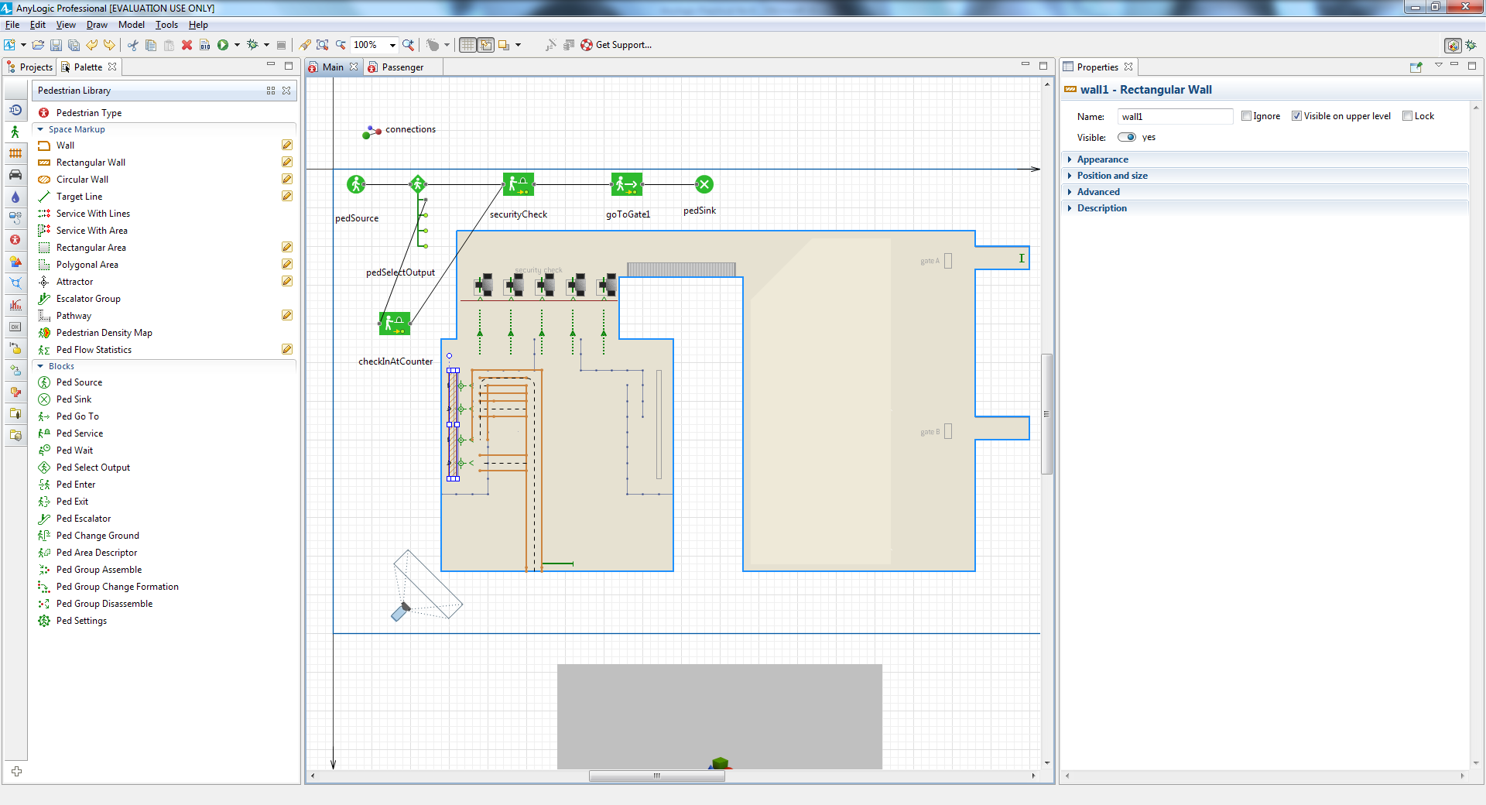

On the Palette’s **3D Objects** tab, select the **Office** section, and then drag four

copies of the **Table** object on to the diagram

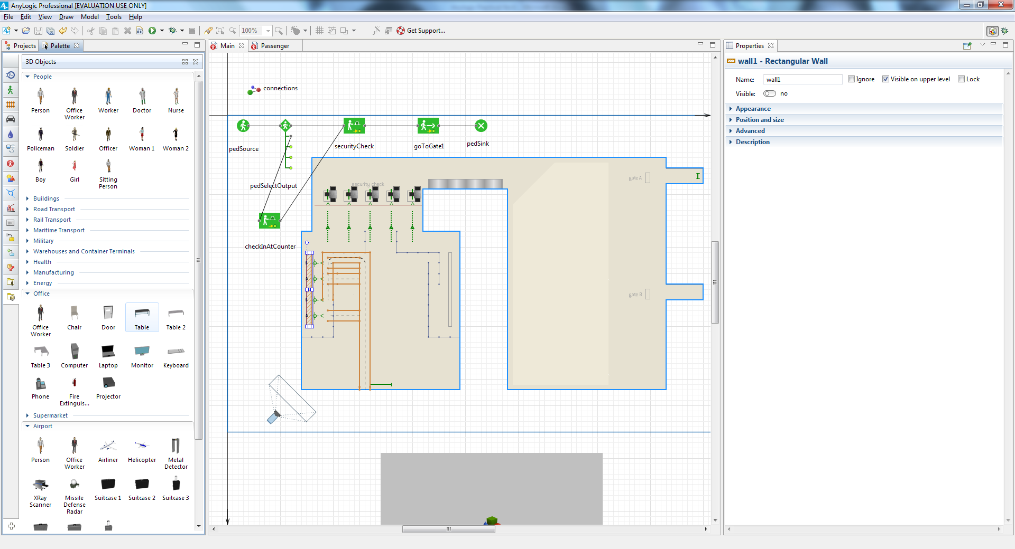

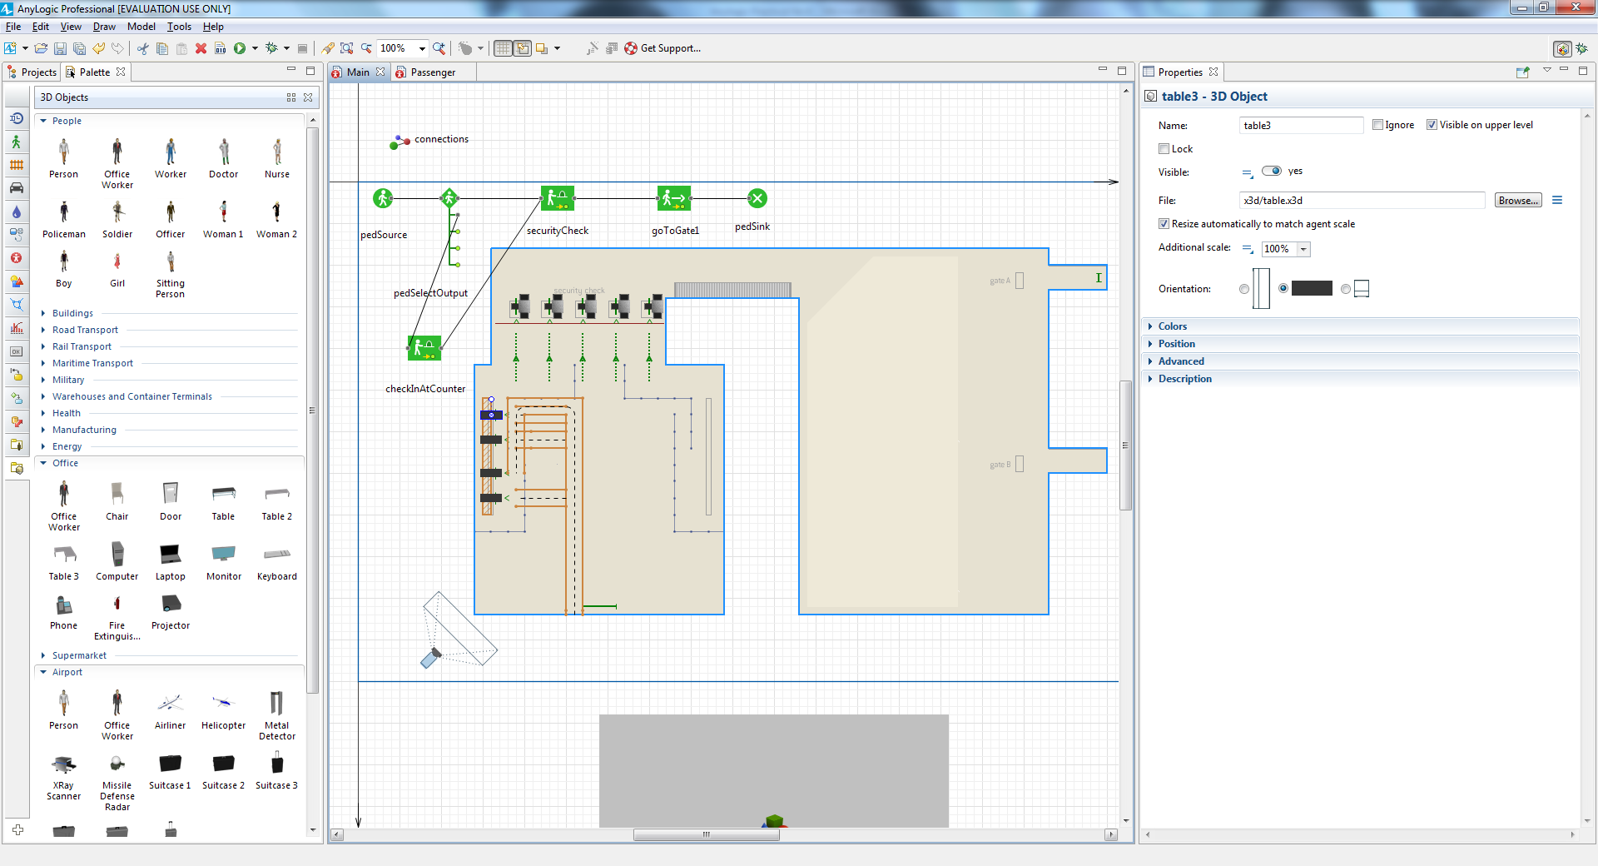

Since the tables aren’t facing the

correct direction, use their **Properties** section’s **Position** area to set **Rotation,**

**Z**: 90 degrees.

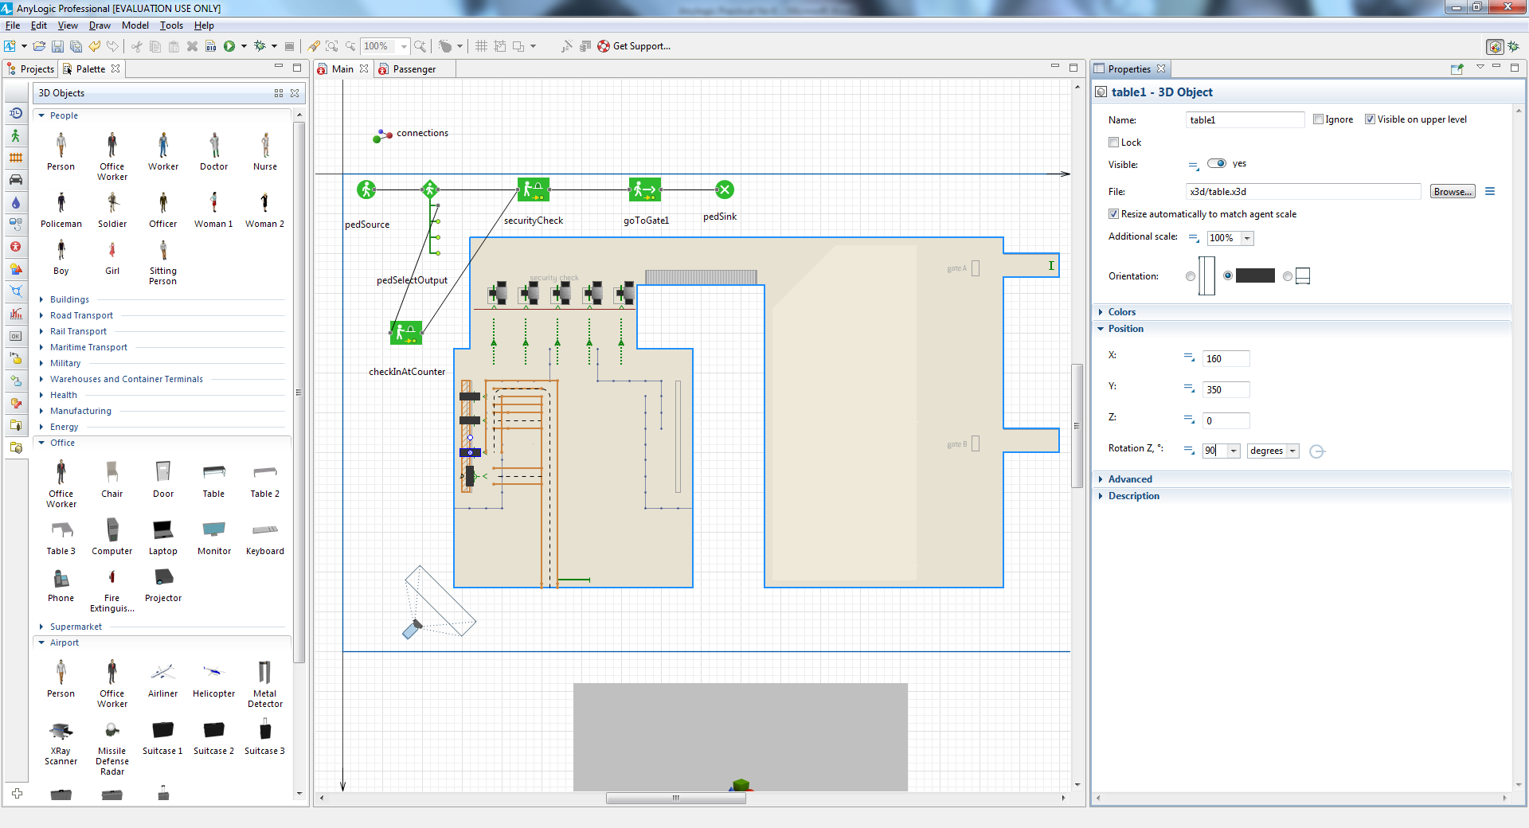

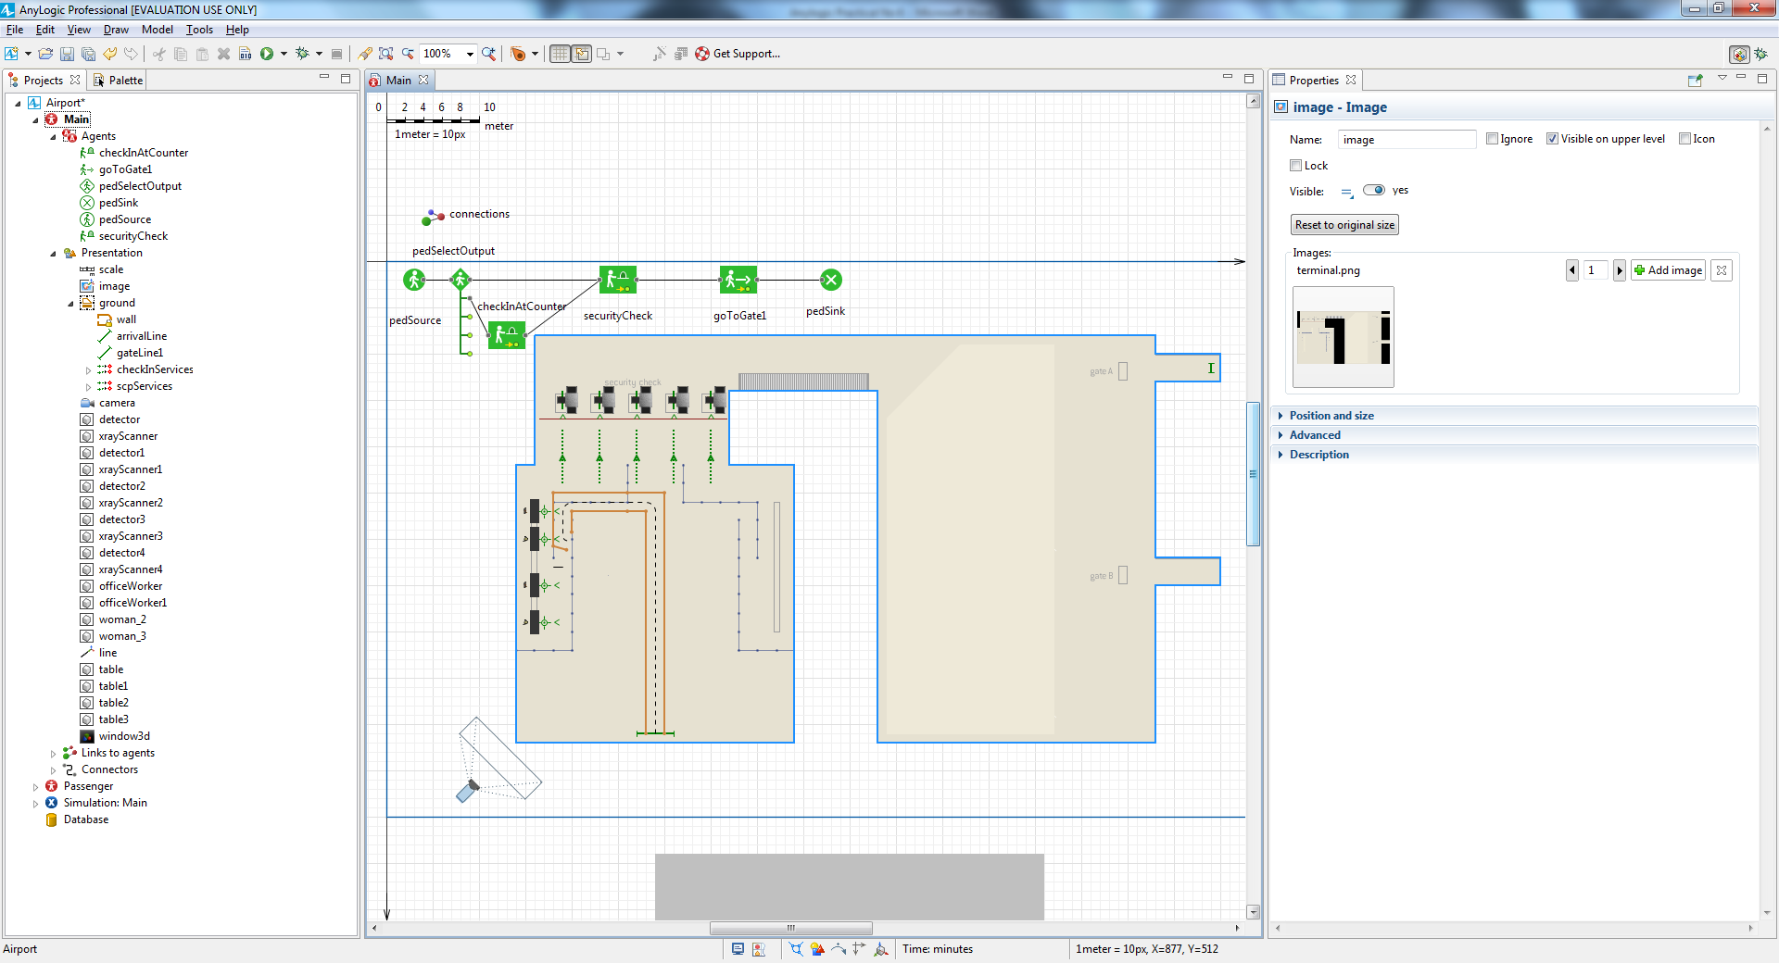

Run the model. You’ll see some passengers check in and then go through the

metal detector.

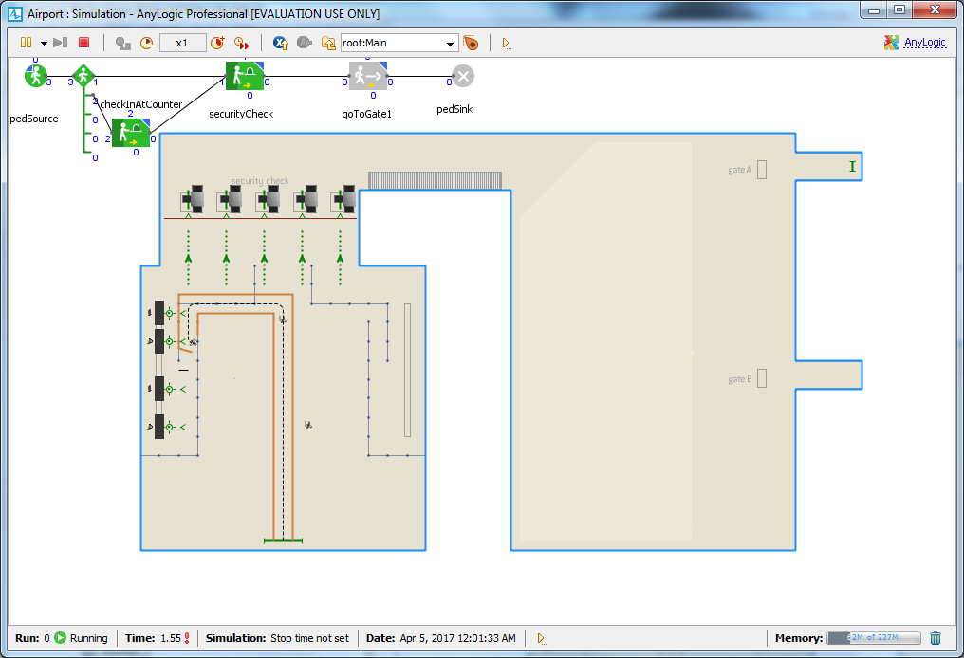

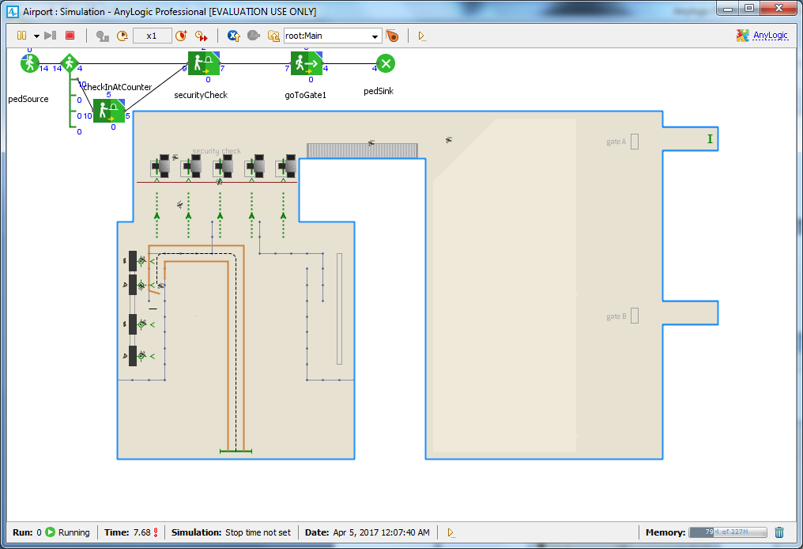

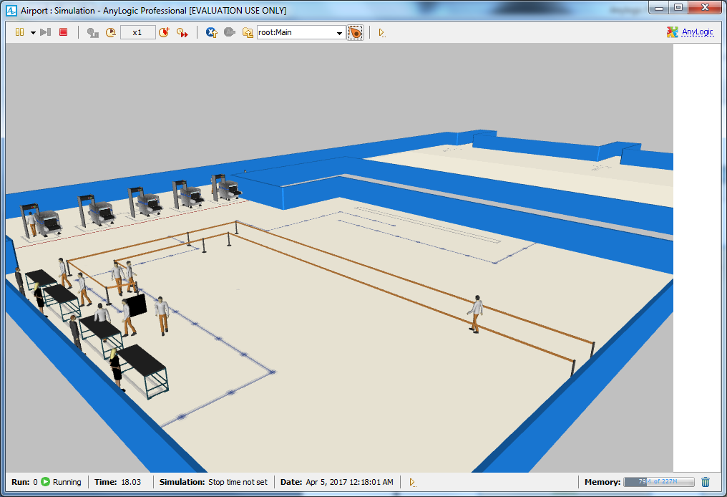

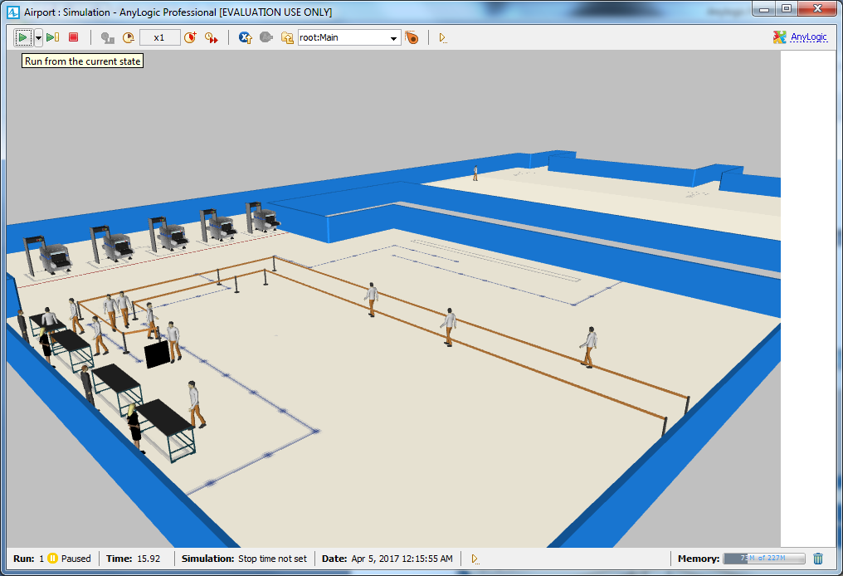

We want the passengers to wait before they go to the gate. To do this, we need to

draw the waiting area where the passengers will wait and then add a flowchart

block (**PedWait**) to simulate the waiting.

Draw the waiting area before the gates using the **Polygonal Area** element

from the **Space Markup** section of the **Pedestrian Library** palette. Switch to the

drawing mode and draw the area as shown in the figure below by clicking

your mouse each time you want to add a point. When you’re finished, doubleclick

your mouse.

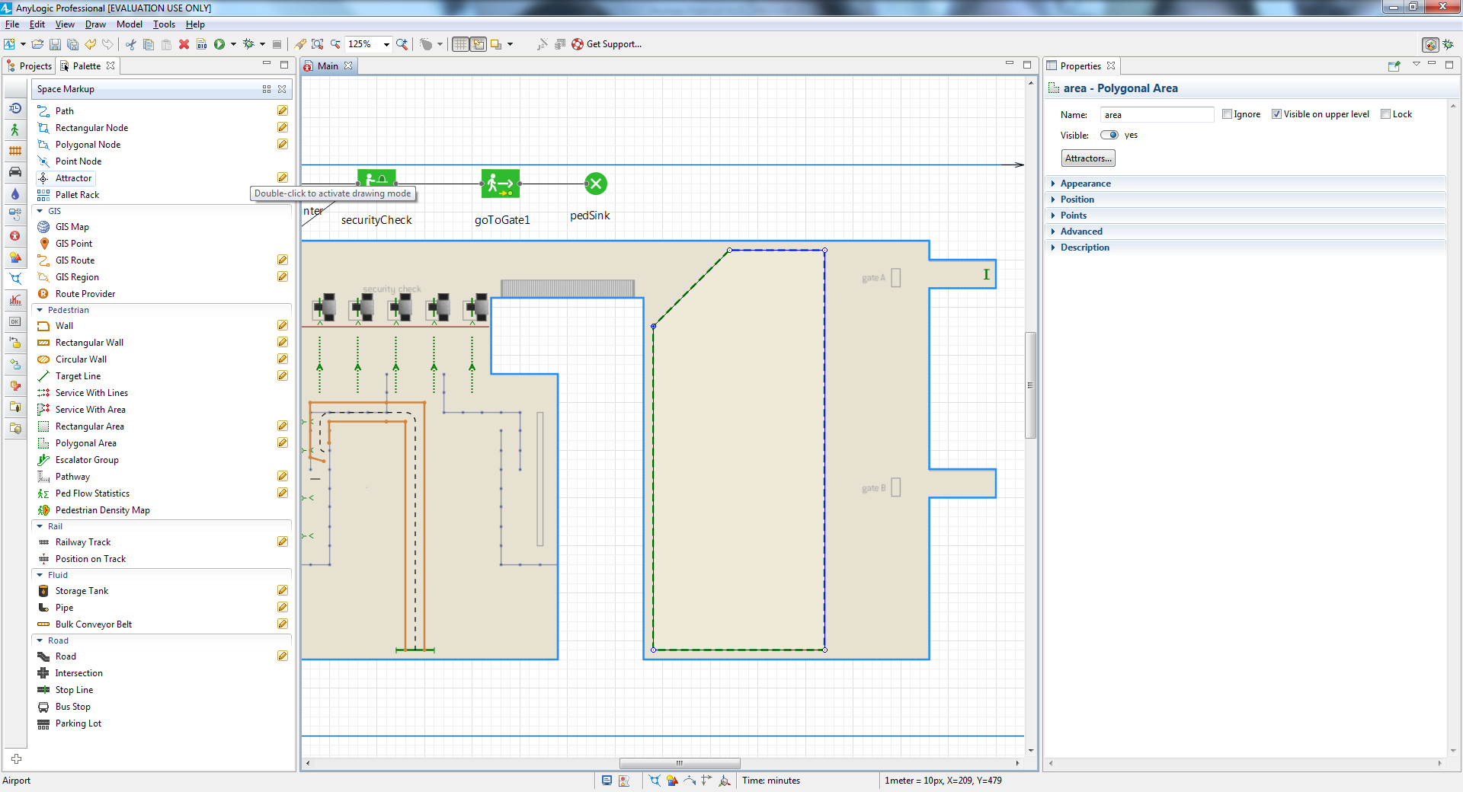

Add the **PedWait** block on to the flowchart between **PedService (securitycheck)** and

**PedGoTo**.(gotogate1) as shown below

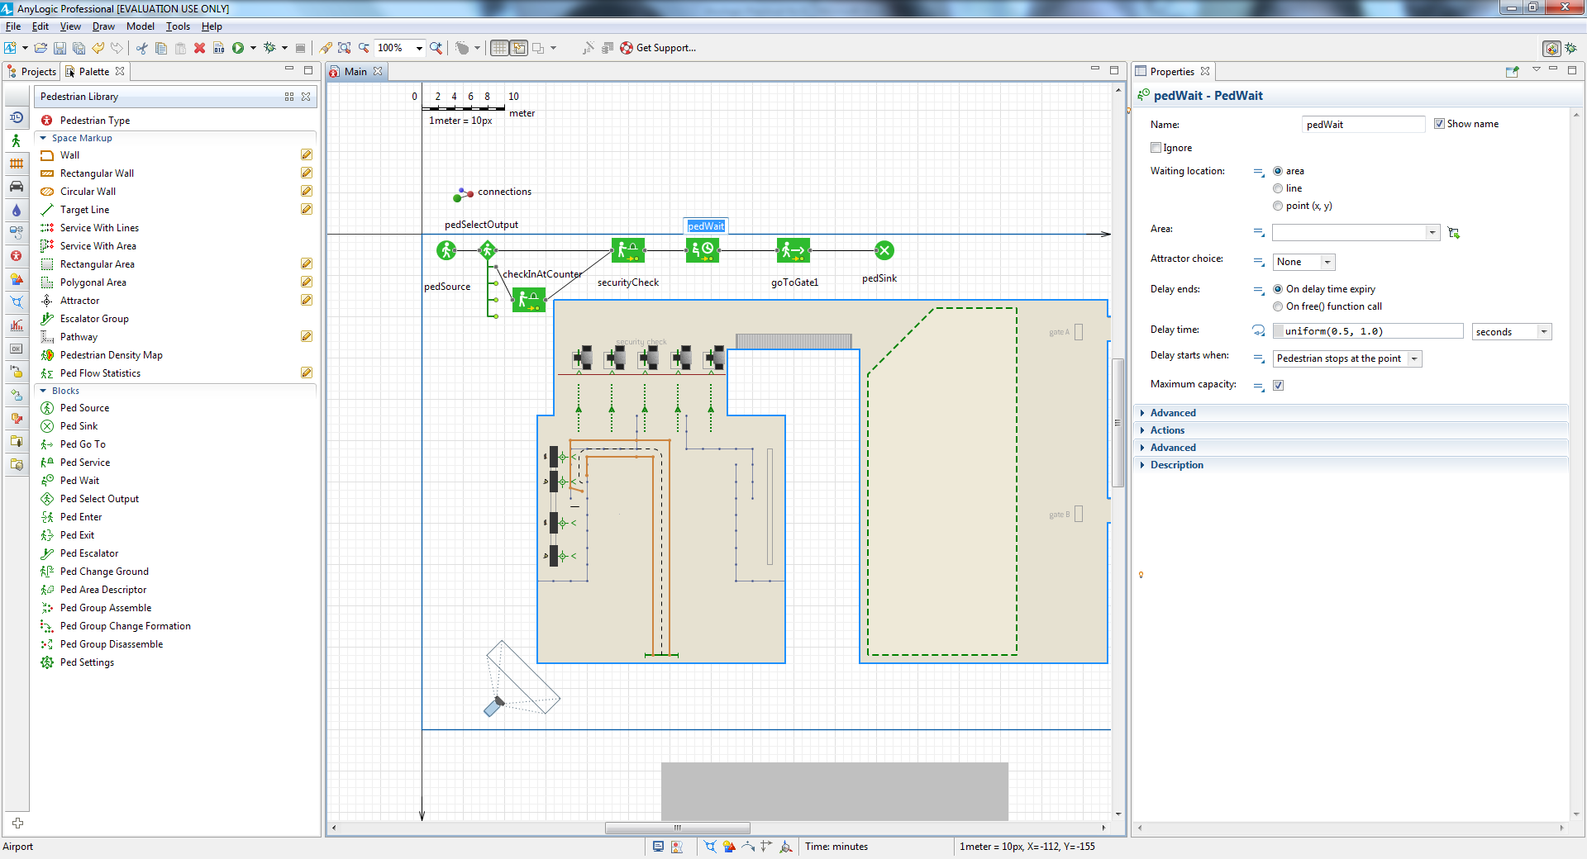

Modify the block’s properties by selecting the area from the **Area** list, and

then setting the **Delay time** to uniform(15, 45) **minutes**.

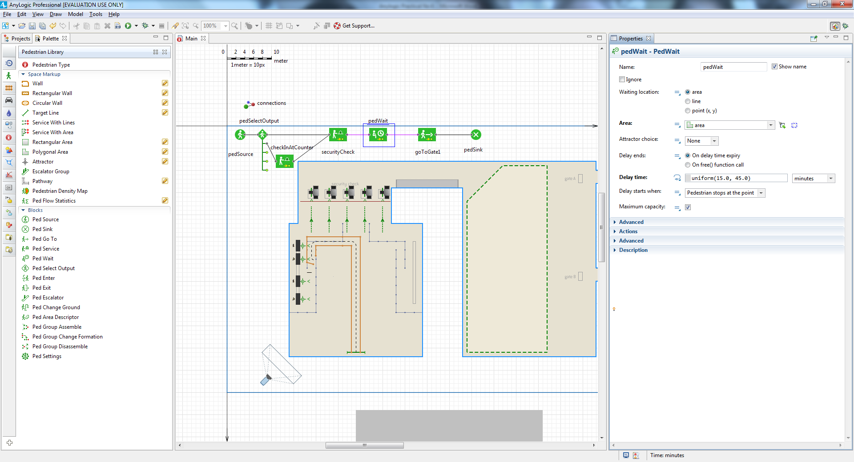

Run the model again, and you’ll see the passengers now wait in the waiting

area before they proceed to the gate.

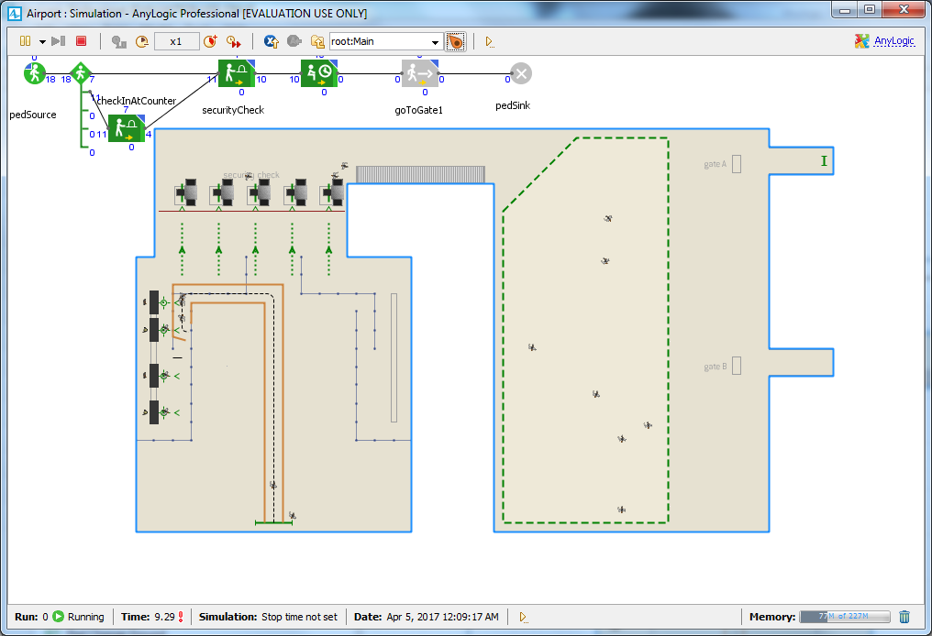

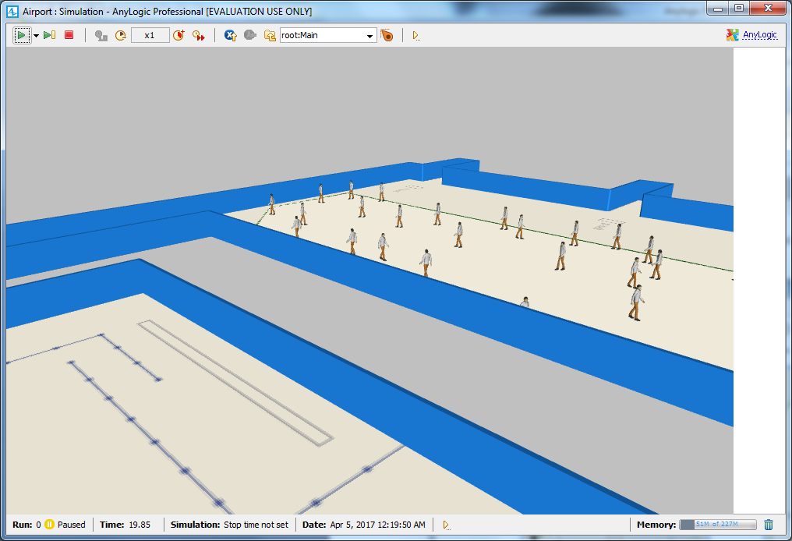

You can add more check-in facilities on the right and configure the

**PedSelectOutput** to separate the pedestrian flow to more branches.

**Defining the boarding logic**

In the **Projects** tree, open the Passenger agent type diagram by double-clicking the Passenger item.

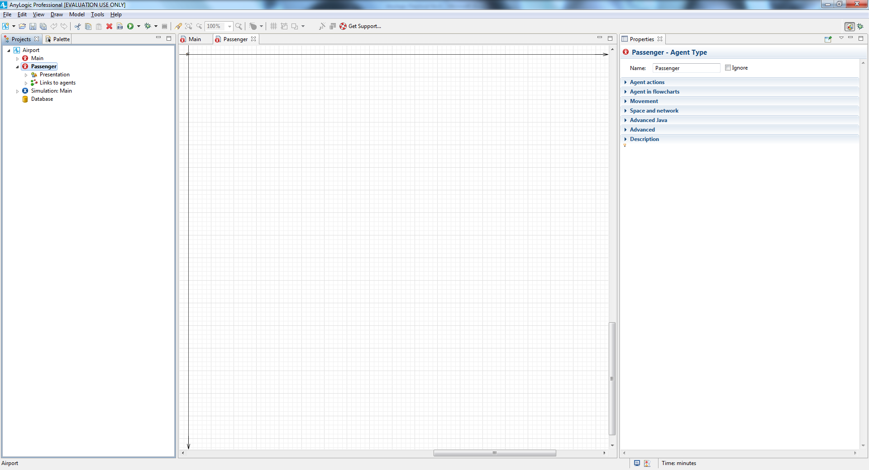

Add a **Parameter** from the **Agent** palette to define the passenger’s class.

Name it business, and set **Type**: Boolean. If the parameter is equal to true, this

is a business class passenger, otherwise (if the parameter is false), this is an

economy class passenger.

We want to distinguish passengers in 3D animation, namely animate business

class and economy passengers with different 3D models. To do this, we’ll use the

existing Person 3D object to represent economy passengers and add another 3D

shape to represent business class passengers.

Add the 3D object **Office worker** to animate a business class passenger and

then place the figure on the axis origin point (0,0), right on the Person shape.

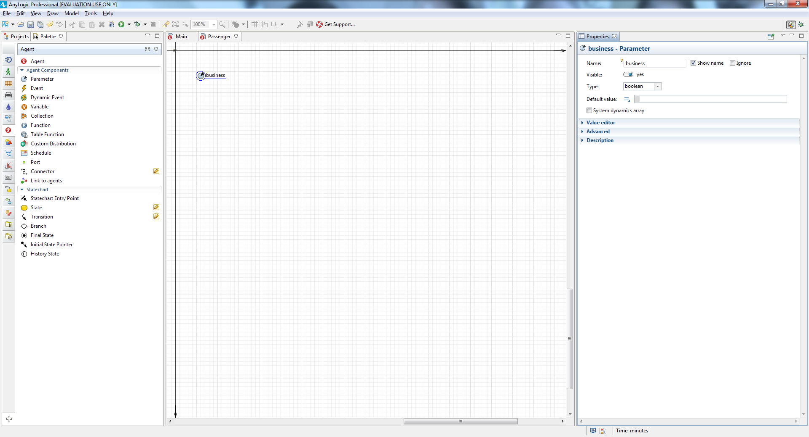

We can distinguish passengers in 3D animation, namely animate business

class and economy passengers with different 3D models. To do this, we’ll use the

existing Person 3D object to represent economy passengers and add another 3D

shape to represent business class passengers.

Add the 3D object **Office worker** to animate a business class passenger and

then place the figure on the axis origin point (0,0), right on the Person shape.

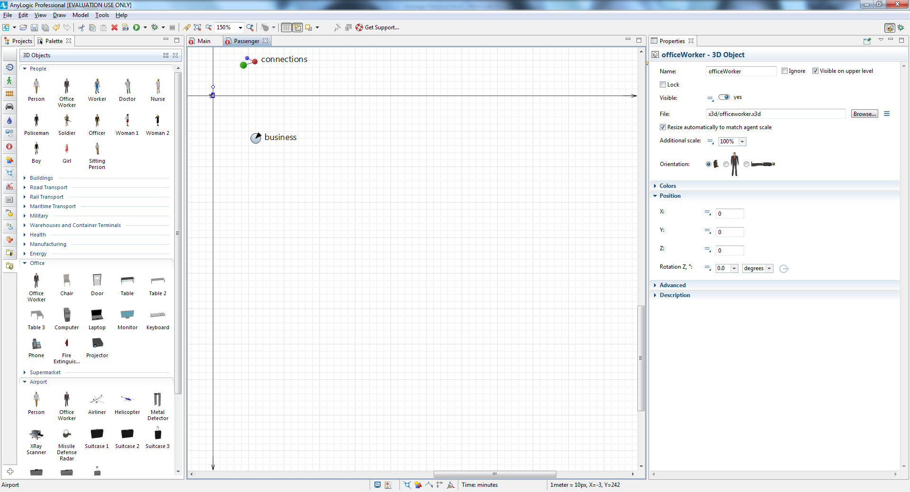

Change the visibility of these objects. First, click the Office worker shape. We

want this shape to be visible only when this is a business class passenger, that

is, when its business parameter is true. Switch to the **Visible** property’s

dynamic value editor by clicking the icon to the right of the **Visible** label,

and then type business in the box. By doing this, we’re making this 3D shape

visible only when pedestrian’s business parameter is true.

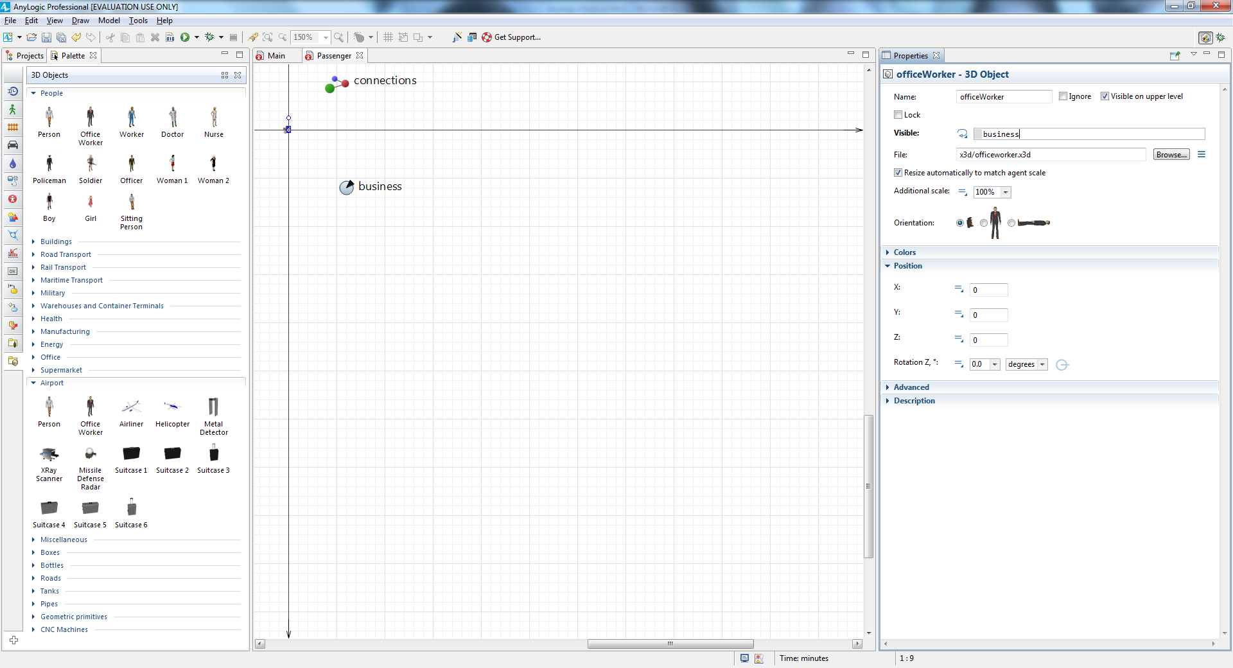

Now select the person 3D object (you can do this from **Projects** tree), and set

**Visible**: ! business . This shape will be visible only if the passenger is an

economy passenger.

The symbol ! is the boolean operand NOT. The expression !business returns

true when the business is NOT true – when the passenger is not a business

class passenger but is an economy passenger

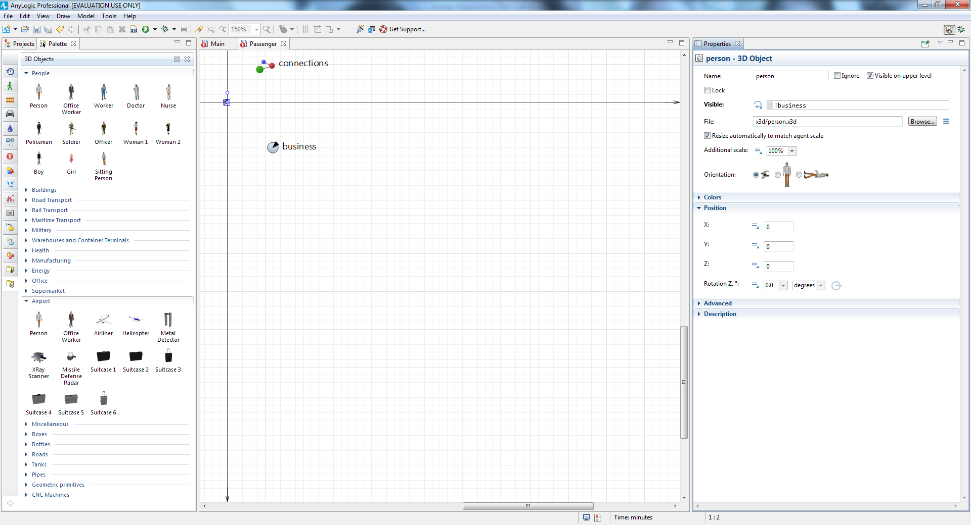

We want to set up the passengers’ class when they arrive to the airport terminal.

Return to the Main diagram and add a **Function** from the **Agent** palette. Name it setupPassenger.

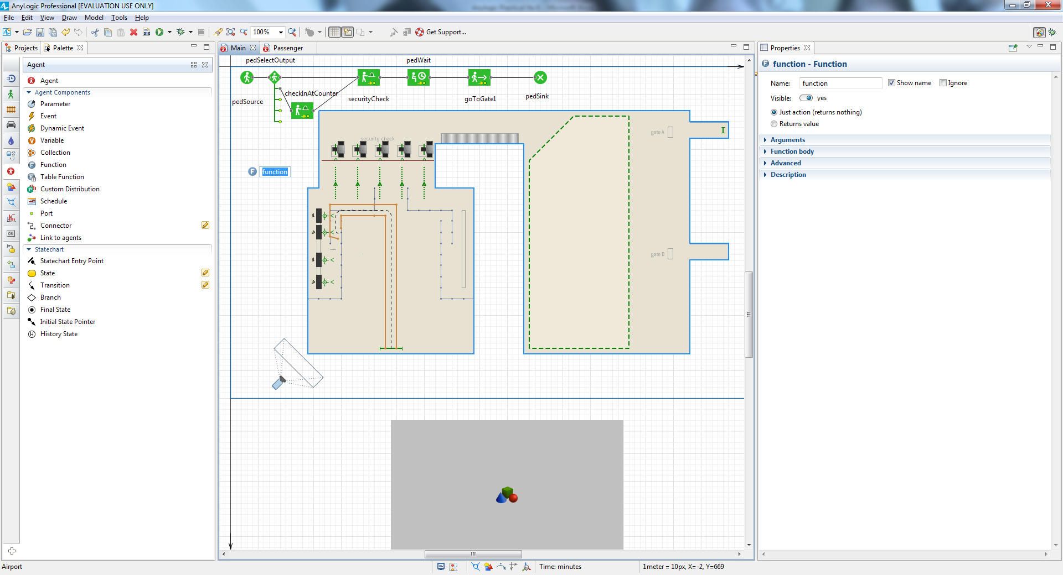

Configure the function as follows:

• Create one argument in the agument drop down list to pass the newly-created passenger to the function:

**Name**: ped

**Type**: Passenger

• The function’s code defines the frequency with which the business class

passengers appear in the model:

in the function body list write this

ped.business = randomTrue(0.15);

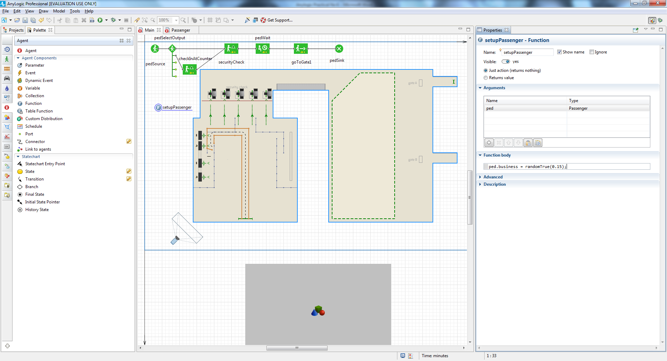

In this case, ped is the function’s argument, of type Passenger. Having set up the

Passenger as the argument type, we can directly access the custom pedestrian

field business simply as ped.business. The function randomTrue(0.15) returns true

in an average of 15 percent of cases, which means an average of 15 percent of our

model’s passengers will travel in business class.

Call this function when a new pedestrian is created by the pedSource block. In

the pedSource properties area, click the arrow to expand the **Actions** section,

and then enter the following code in the **On exit** box: setupPassenger(ped);

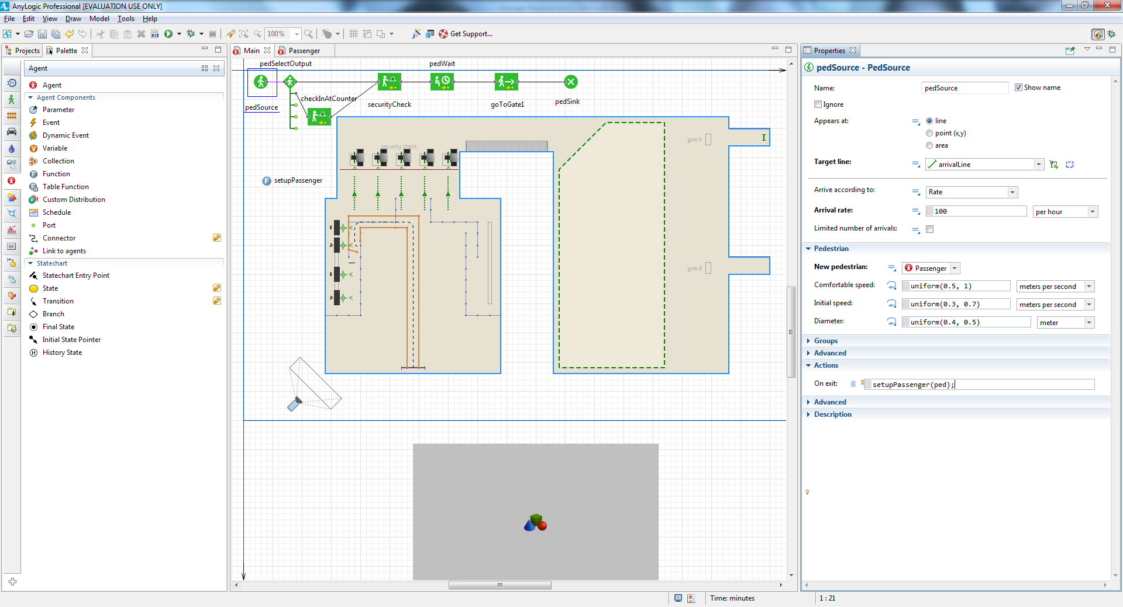

Here we call our function setupPassenger for the newly-created pedestrian. This

pedestrian is passed to the function via its argument.

Draw two services with lines for the upper gate, one for business class and one for

economy passengers.

Draw a Service with Line, defining the priority line (point service, 1 service, 1

line). Name this service business1

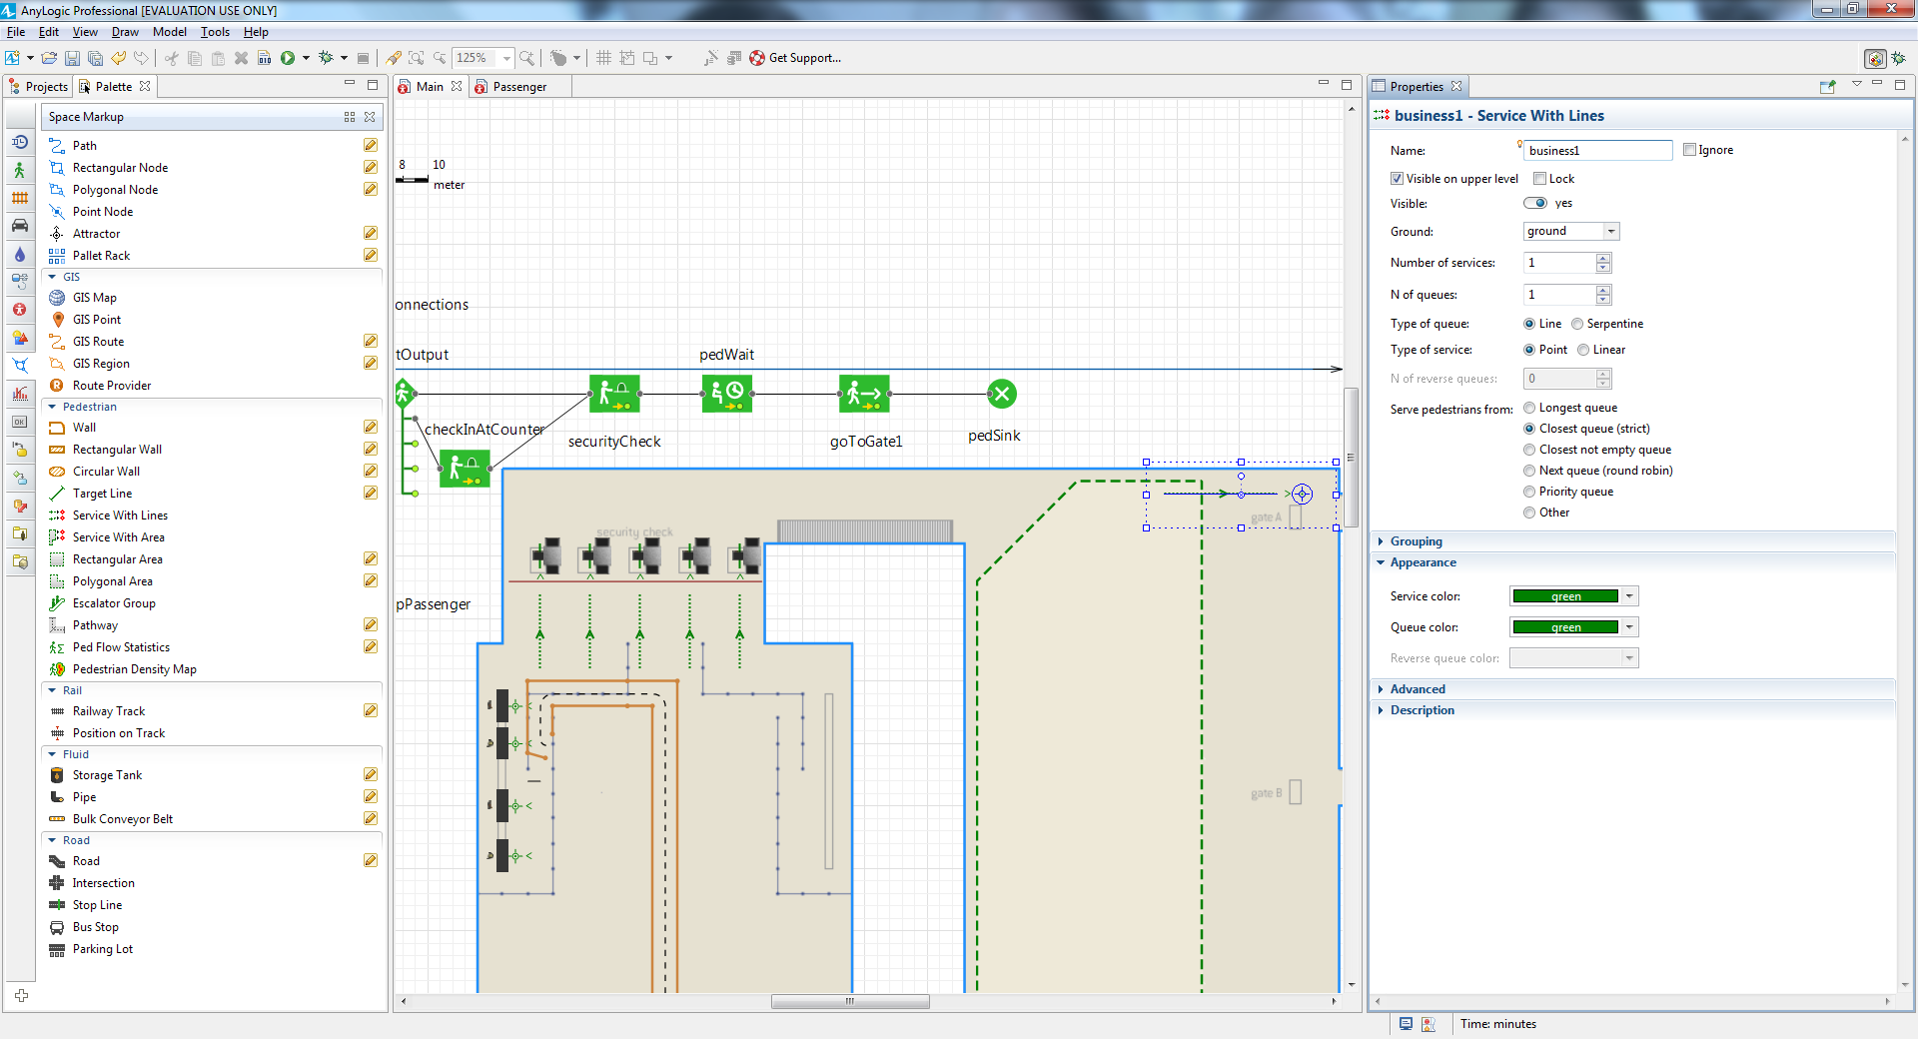

Add one more Service with Line, and name it economy1

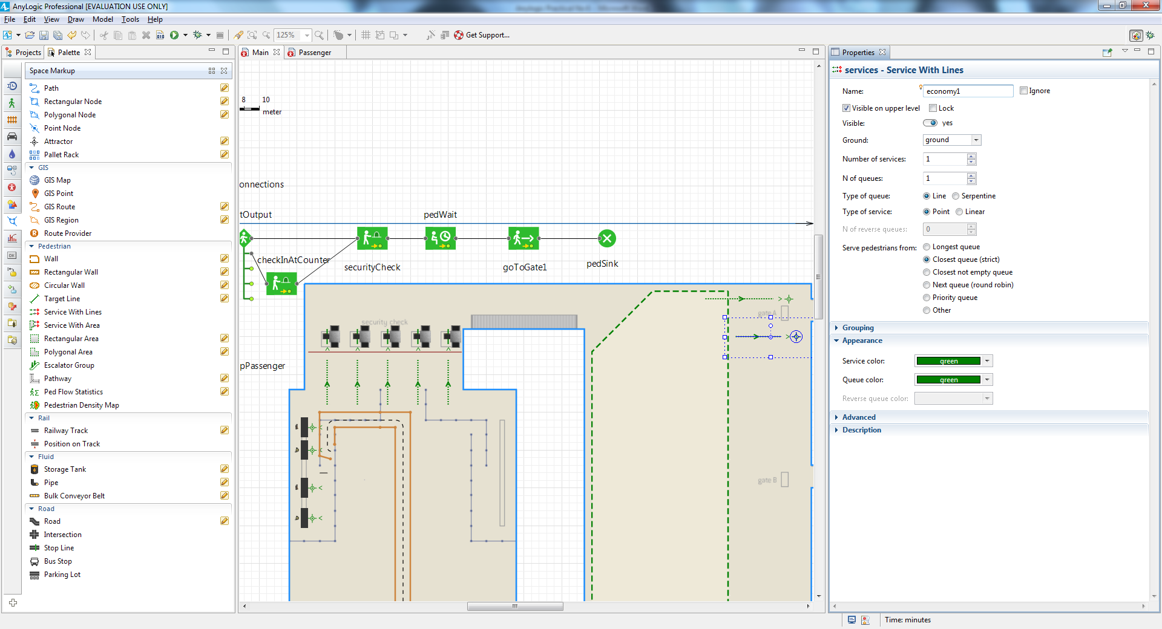

Add more point to the queue

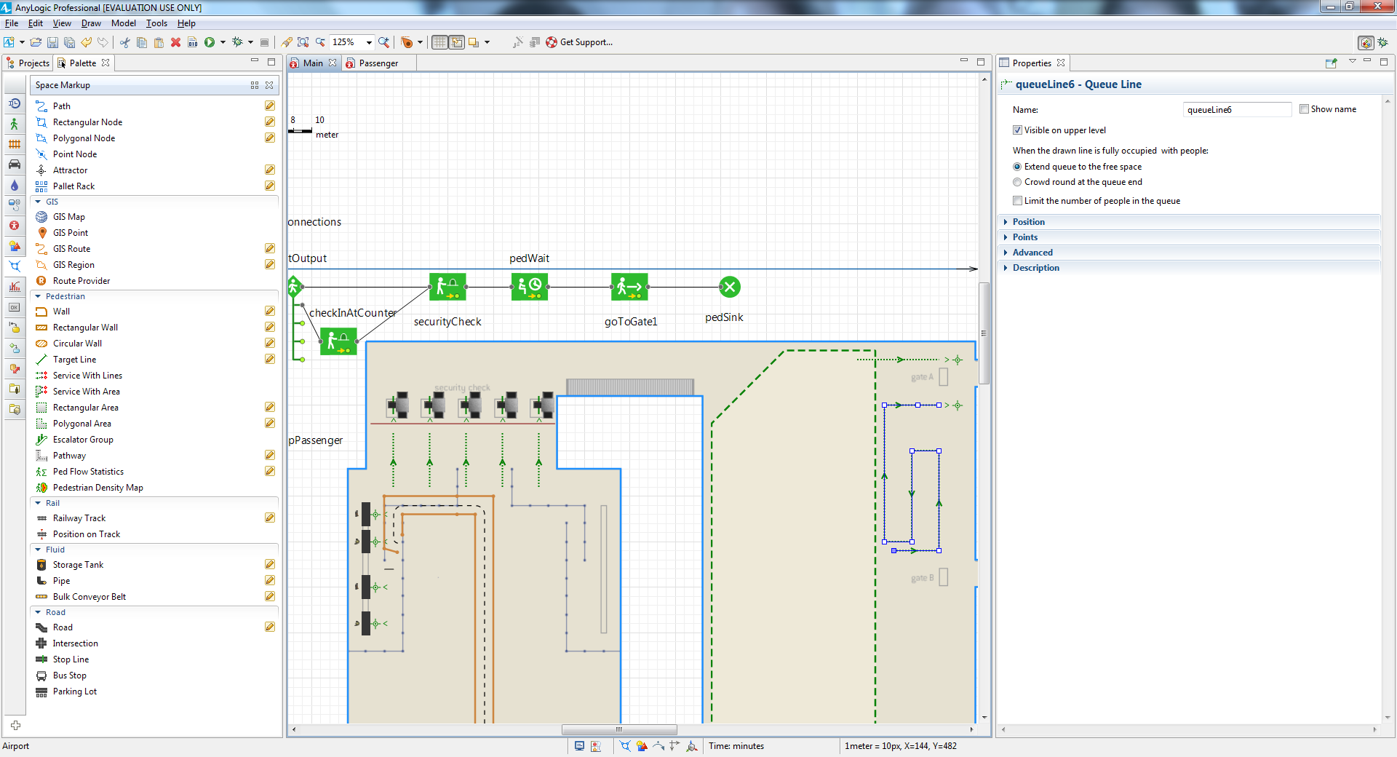

Draw an area at the gate with the **Rectangular Wall** element, from the apce markup and then add

a table from 3d office & rotate it 90 degree as per display and add two 3D woman models at the table.

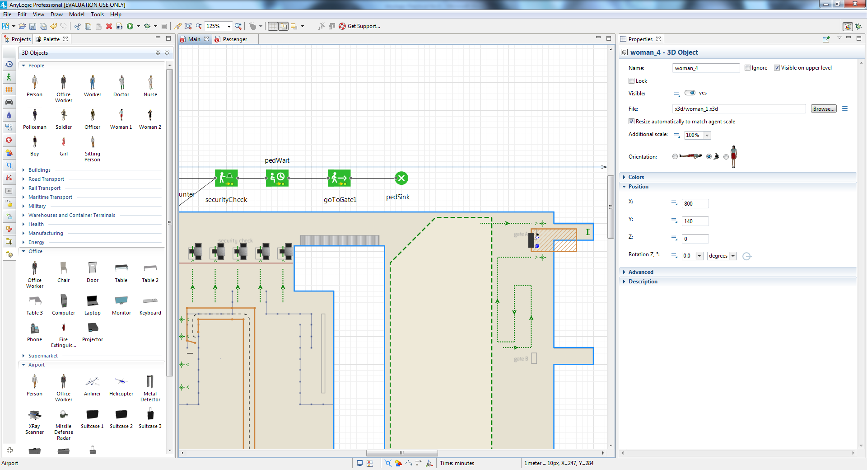

In the wall's properties, set **Visible** to **no** to make this wall invisible at the model runtime.

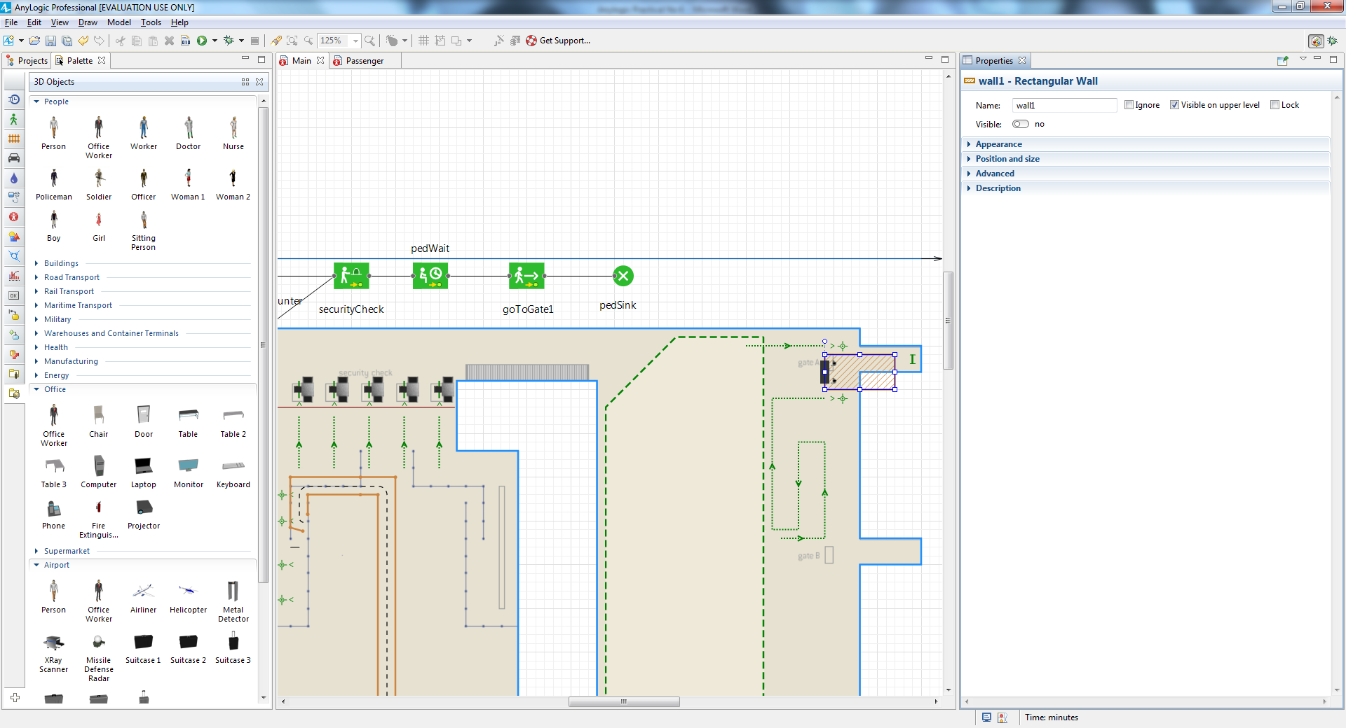

Insert the blocks into the flowchart between the pedWait and goToGate1 objects.

Add **PedSelectOutput** to route business class and economy passengers to

different lines. As shown below

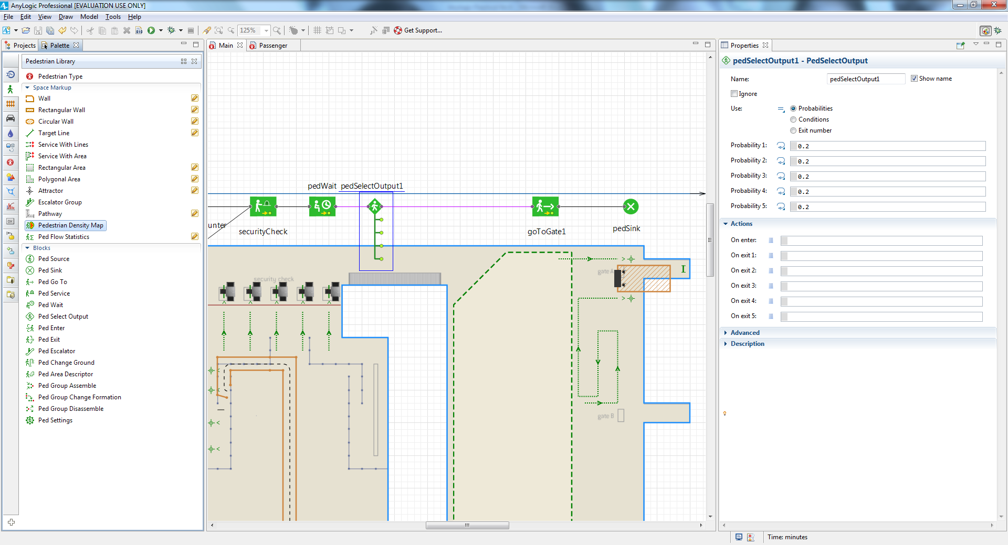

Add two **PedService** blocks: businessBoarding1 and economyBoarding1 to

simulate the process of checking passengers’ tickets at the gate.

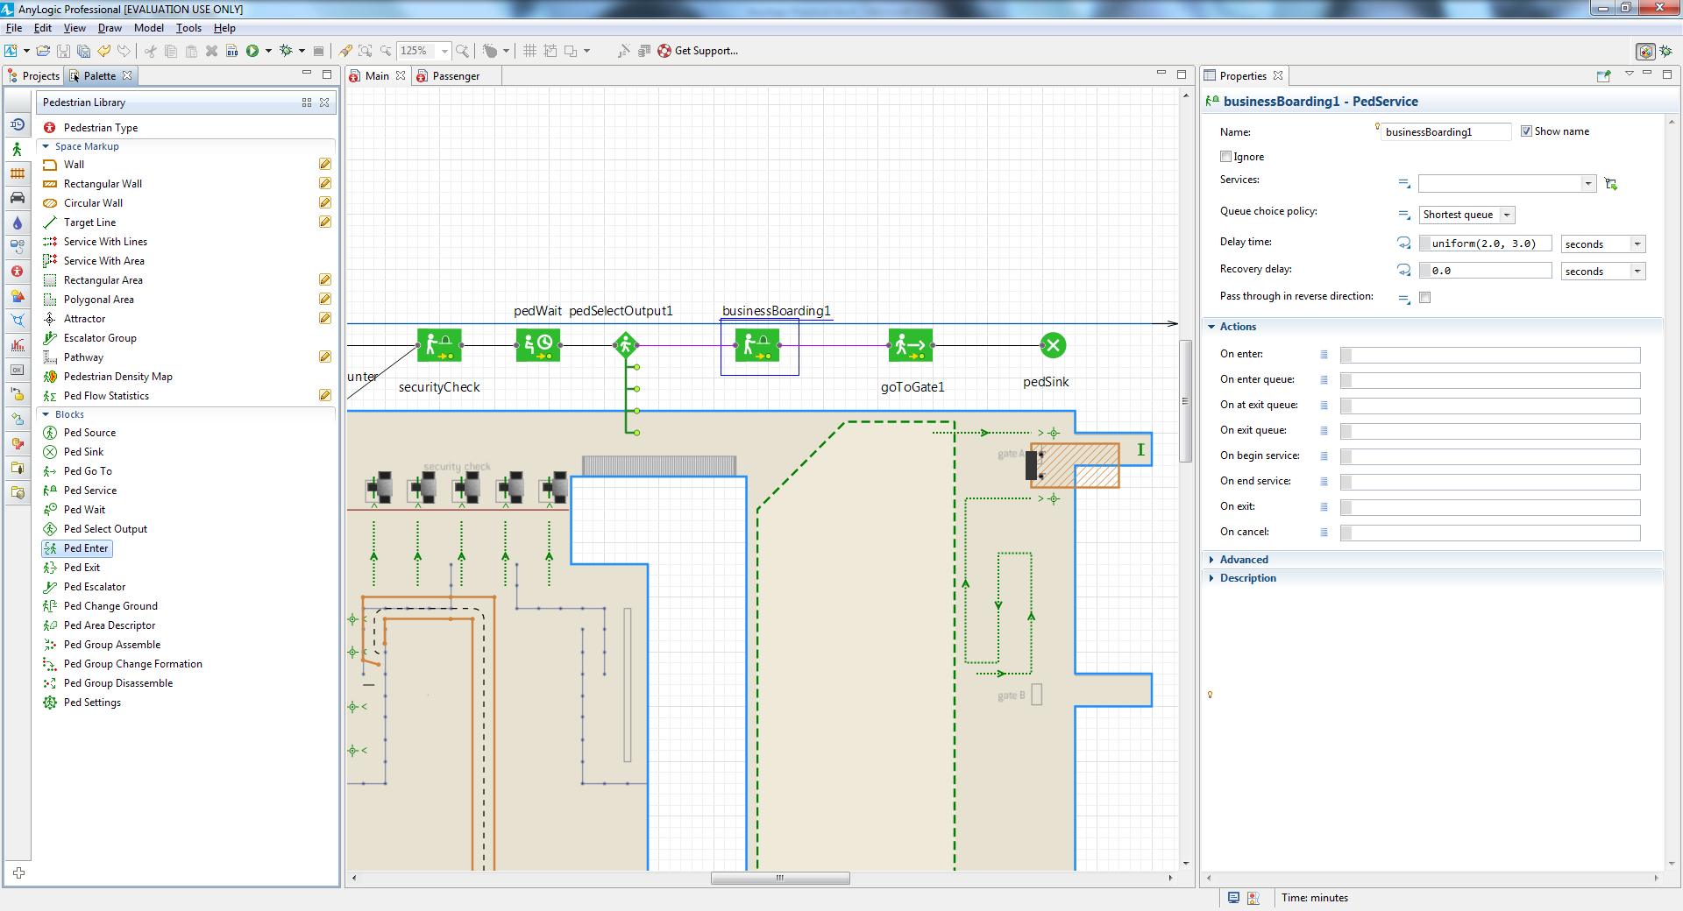

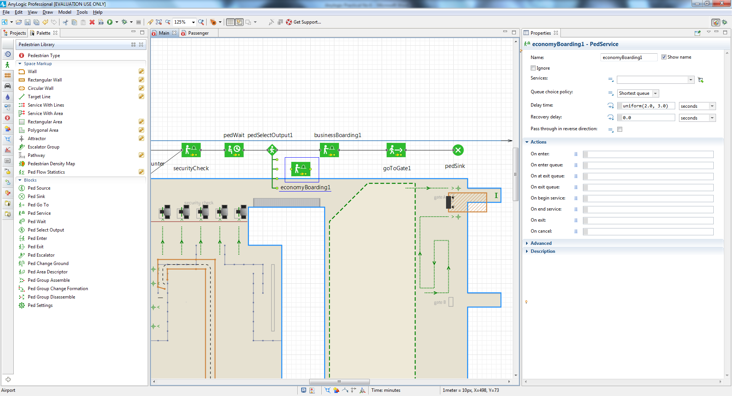

Connect it as shown in the figure below

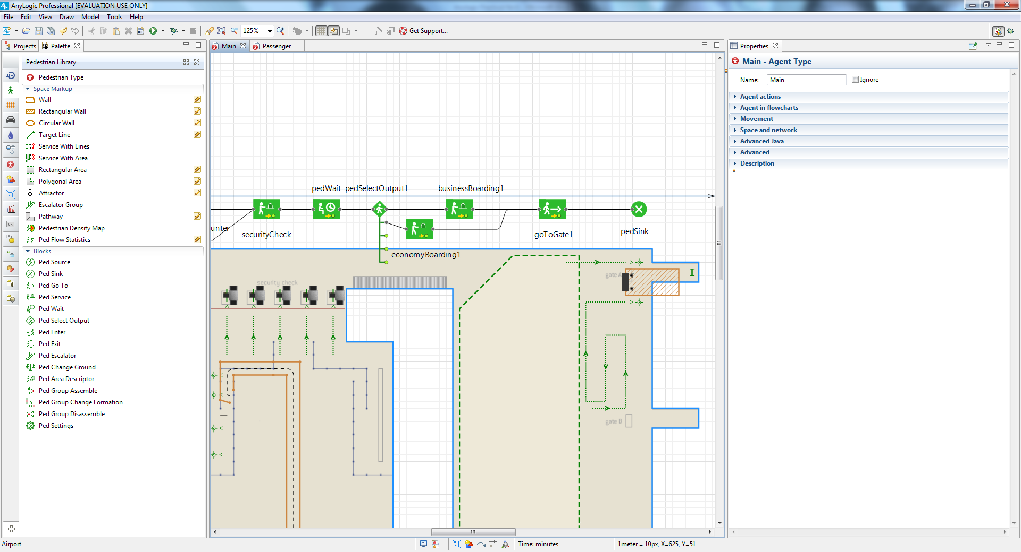

Since the **PedSelectOutput** block routes business class and economy

passengers to different lines, select **Use**: **Conditions**, and then type

ped.business in the **Condition 1** box. This expression will return true for all

business class passengers, which means they will follow the upper flowchart

branch and join the priority line. After you set up the conditions for the

block’s next output ports (true, false, false), the model will direct all other

passengers to the second output port.

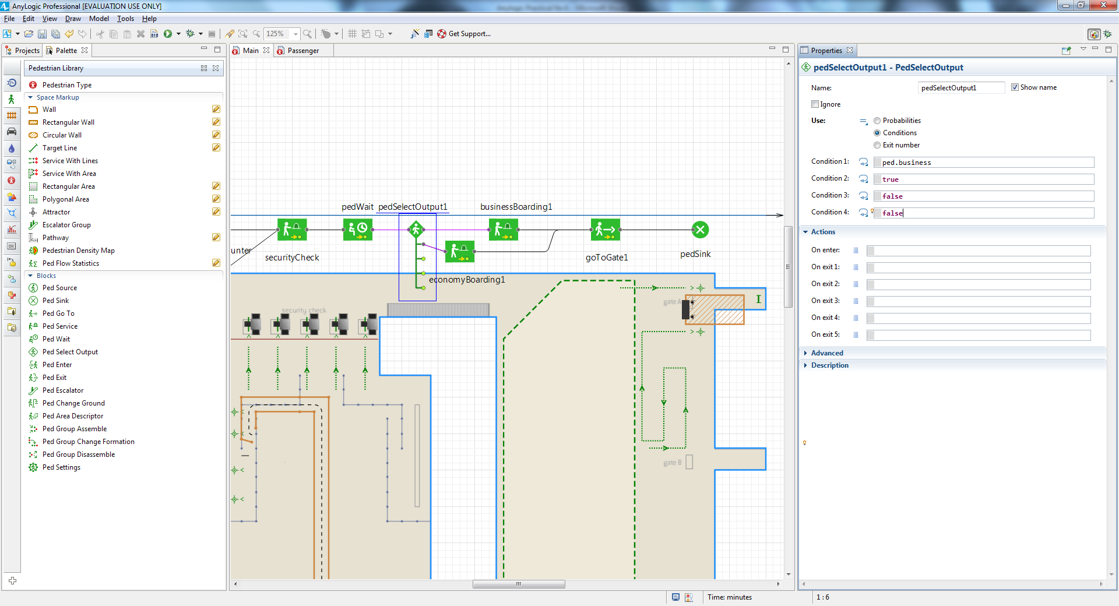

For the **PedService** block businessBoarding1, choose business1 as **Services**.

Since it takes between two to five seconds to check a passenger’s ticket, you

can slightly change the **Delay time**.

For economyBoarding1, set **Services**: economy1, adjust the **Delay time**.

Run the model. You’ll see passengers pass the checkpoint, and a small number

of them will take the priority line.

